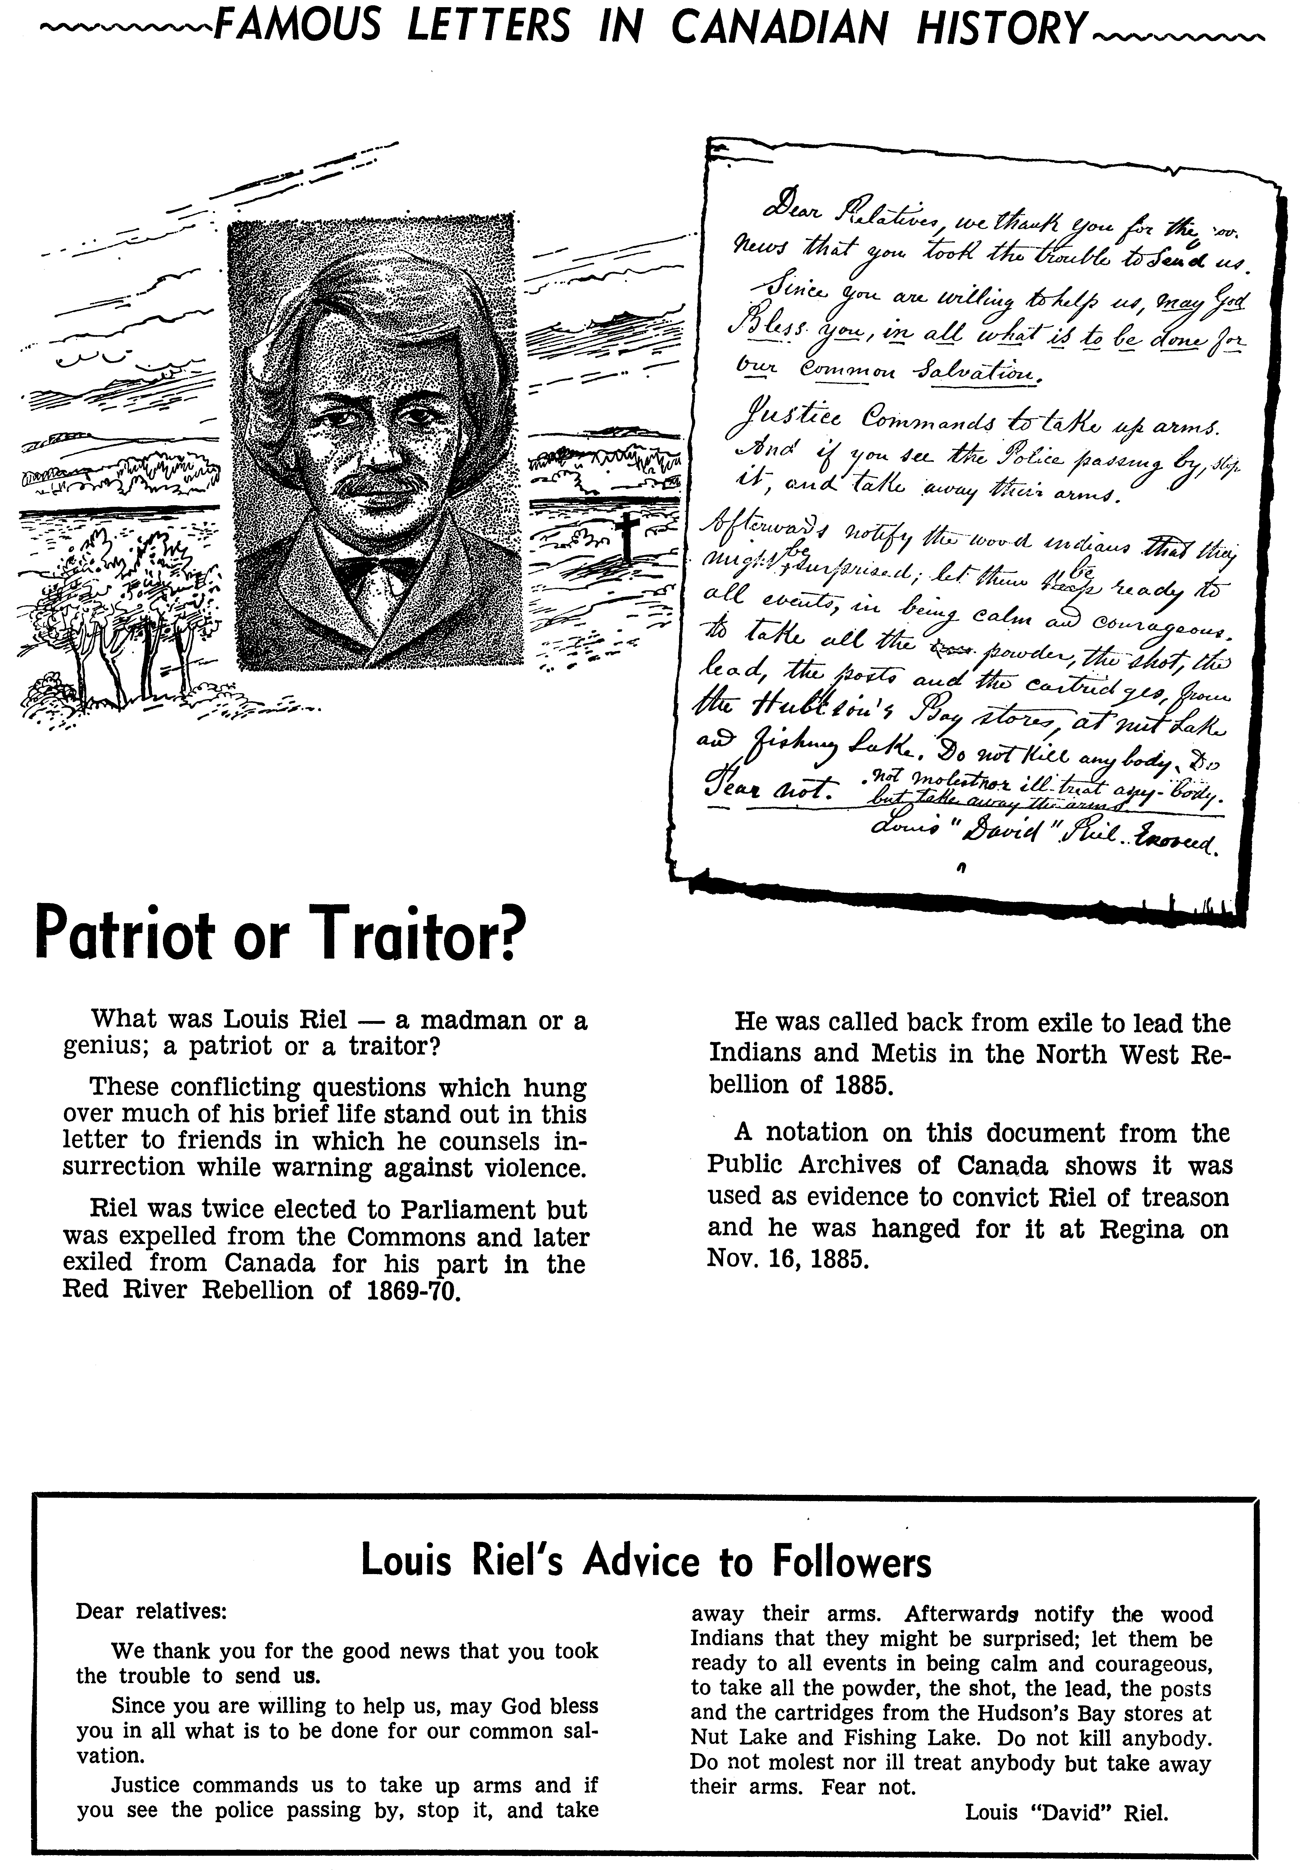
Reproduced from Famous Letters in Canadian History. Copyright 1964. Used by permission of Pat Jacobsen, on behalf of the late Peter Jackman.
What was Louis Riel – a patriot or a traitor?
This conflicting question which hung over much of his brief life stands out in this letter to friends in which he counsels insurrection while warning against violence.
Riel was twice elected to Parliament but was expelled from the Commons and later exiled from Canada for his part in the Red River Rebellion 1869-70.
He was called back from exile to lead the Indians and Métis in the North West Rebellion of 1885
A notation on this document from the Public Archives of Canada shows it was
used as evidence to convict Riel of treason and he was hanged for it at Regina on
Nov. 16, 1885.

