In 1891, shortly before his death, Prime Minister John A. Macdonald gave a speech urging the Members of Parliament to support allegiance to Britain rather than moving into closer trade ties with the United States.

This speech became very famous, and for many years school children were made to
memorize and recite it. Here is a portion of the speech:

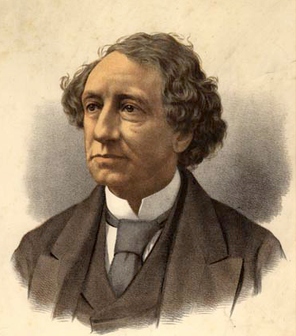

…I commend these issues to your determination, and to the judgment of the whole people of Canada, with an unclouded confidence that you will proclaim to the world your resolve to show yourselves not unworthy of the proud distinction that you enjoy, of being numbered among the most dutiful and loyal subjects of our beloved Queen.

As for myself, my course is clear. A British subject I was born – a British subject I will die. With my utmost effort, with my latest breath, will I oppose the “veiled treason” which attempts by sordid means and mercenary proffers to lure our people from their allegiance. During my long public service of almost half a century I have been true to my country and its best interests, and I appeal with equal confidence to the men who have trusted me in the past, and to the young hope of the country, with whom rests its destinies for the future, to give me their united and strenuous aid in this, my last effort, for the unity of the Empire and the preservation of our commercial and political freedom.

As cited in Morton, D., and M. Weinfeld. “Who Speaks for Canada? Words That Shape a Country”. Toronto, ON: McClelland and Stewart Ltd., 1998. 46.
(page 1 of 2)
Remember that the year is 1891, and that Sir John A. Macdonald is a very old man. As Canada’s first prime minister he has worked long and hard to bring about Confederation and to establish Canada as a country independent from Britain, but still loyal to Britain and to the Crown.

Macdonald argues against free trade between Canada and the United States because he feels that it will gradually destroy Canadian loyalty to Britain, and will lead to Canada becoming a part of the United States. He felt that loyalty and special ties to Britain were an important defining characteristic of Canada.

In Canada today, the reigning Queen or King of England is still the head of our government, and the position is still represented by the Governor-General. However, our law-making and decision-making powers are completely independent from Britain. We are members of the British Commonwealth of nations, but citizens of Canada.

Now, imagine that a prime minister today would be giving a speech in Parliament urging Canada to keep its independence from the United States, and keep its special ties to Britain.

How would the speech be different?
Working with a partner, prepare a version of this speech in your own words.

Main Ideas:
___________________________________________________________________________________________________________________________________________________________________________________________________________________
_________________________________________________
_________________________________________________
(page 2 of 2)

