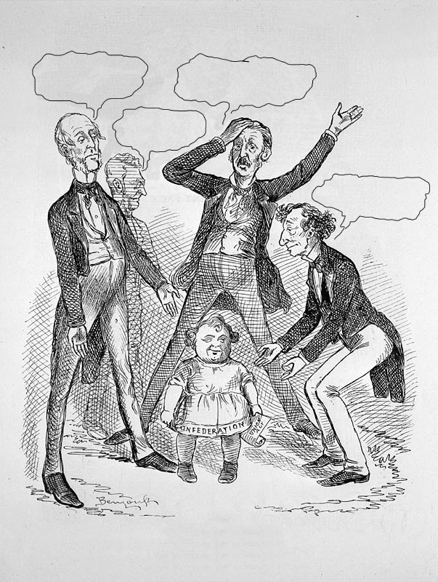

Gracious! Me own child don’t know me!!
Come to your genewine Poppy!

I’m the Father of Confederation.

Don’t it recognise its real Daddy?

CONFEDERATION !
THE MUCH-FATHERED YOUNGSTER.

<http://www.nlc-bnc.ca/2/18/h18-2900-e.html>
Caricature: “Confederation! The much-fathered youngster.”
© Public Domain
Source: National Archives of Canada/C-005812

