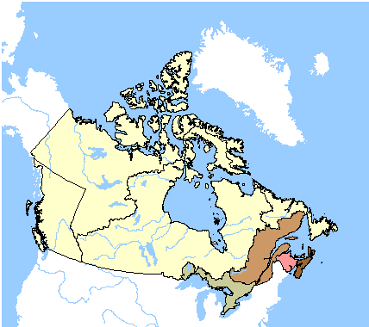

NORTHWEST
TERRITORIES

RUPERT’S LAND

QUÉBEC
ONTARIO
NEW
BRUNSWICK
NOVA SCOTIA

© 2005. Her Majesty the Queen in Right of Canada, Natural Resources Canada. ‹http://atlas.gc.ca>.
Sa Majesté la Reine du chef du Canada, Ressources naturelles Canada.
This map shows the colonies of Canada, Nova Scotia and New Brunswick united in a federal state. The provinces of Nova Scotia and New Brunswick retain their established boundaries, and Canada is divided into the provinces of Ontario and Quebec. New provisional boundaries are assigned to northern Ontario.
Canada’s long and diversified settlement history is reflected in the two distinct patterns of boundaries that differentiate between eastern and western Canada. The eastern boundaries closely conform to natural features such as drainage basins, while boundaries of western and northern Canada reflect the administrative organisation of these lands by, first, the Hudson’s Bay Company and later the Government of Canada.

