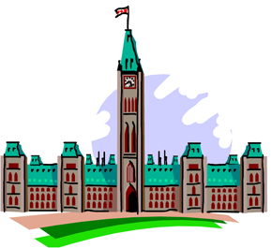
At the time of the Rebellions of 1837 and 1838, the colonies of British
North America had Representative Government, or, a Legislative Assembly elected by eligible voters to represent them in government. The Legislative Assembly could impose taxes and propose laws affecting local matters, but their actions needed the approval of the Governor General and all the other appointed (non-elected) members of the British colonial government. It was very important to the people to obtain not only representative government, but also Responsible Government.

Complete the following Concept Overview to explain what is meant by responsible government.
Characteristics of Responsible Government: | Illustration
What is it like? | What is it unlike?
Definition in your own words: | Names of leaders in early Canada who promoted responsible government:
Why you think responsible government is important?

