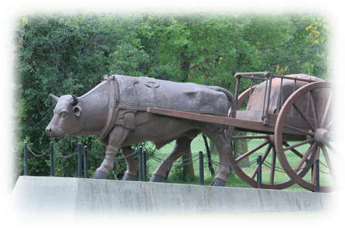
Ireland
England
jobs
poverty
starvation
wooden sailing ships
ox carts
Scottish crofters
overcrowded cities
industries
sheep farmers
land grants
Scottish Highlands
rich landowners
Lord Selkirk
clearances of lands
famines
potato farms
droughts
Scotland
factories
lost farms
farmers
long voyage
new farmlands

