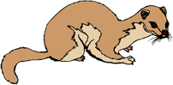 | Fur-Trade Route of the  North West Company | Fur-Trade Route of the Hudson’s Bay Company
Describe the route.
What are the advantages of this route?
What are the disadvantages of this route?
Describe how the routes are similar. |  | (page 1 of 2)
Describe how the routes are different.
Note two historical consequences of each route. | 1.  2. |  | 1.  2.
Draw out the routes in two different colours on a map of Canada. Write a concluding statement about the effects of both fur-trade routes on the history of Canada.

(page 2 of 2)

