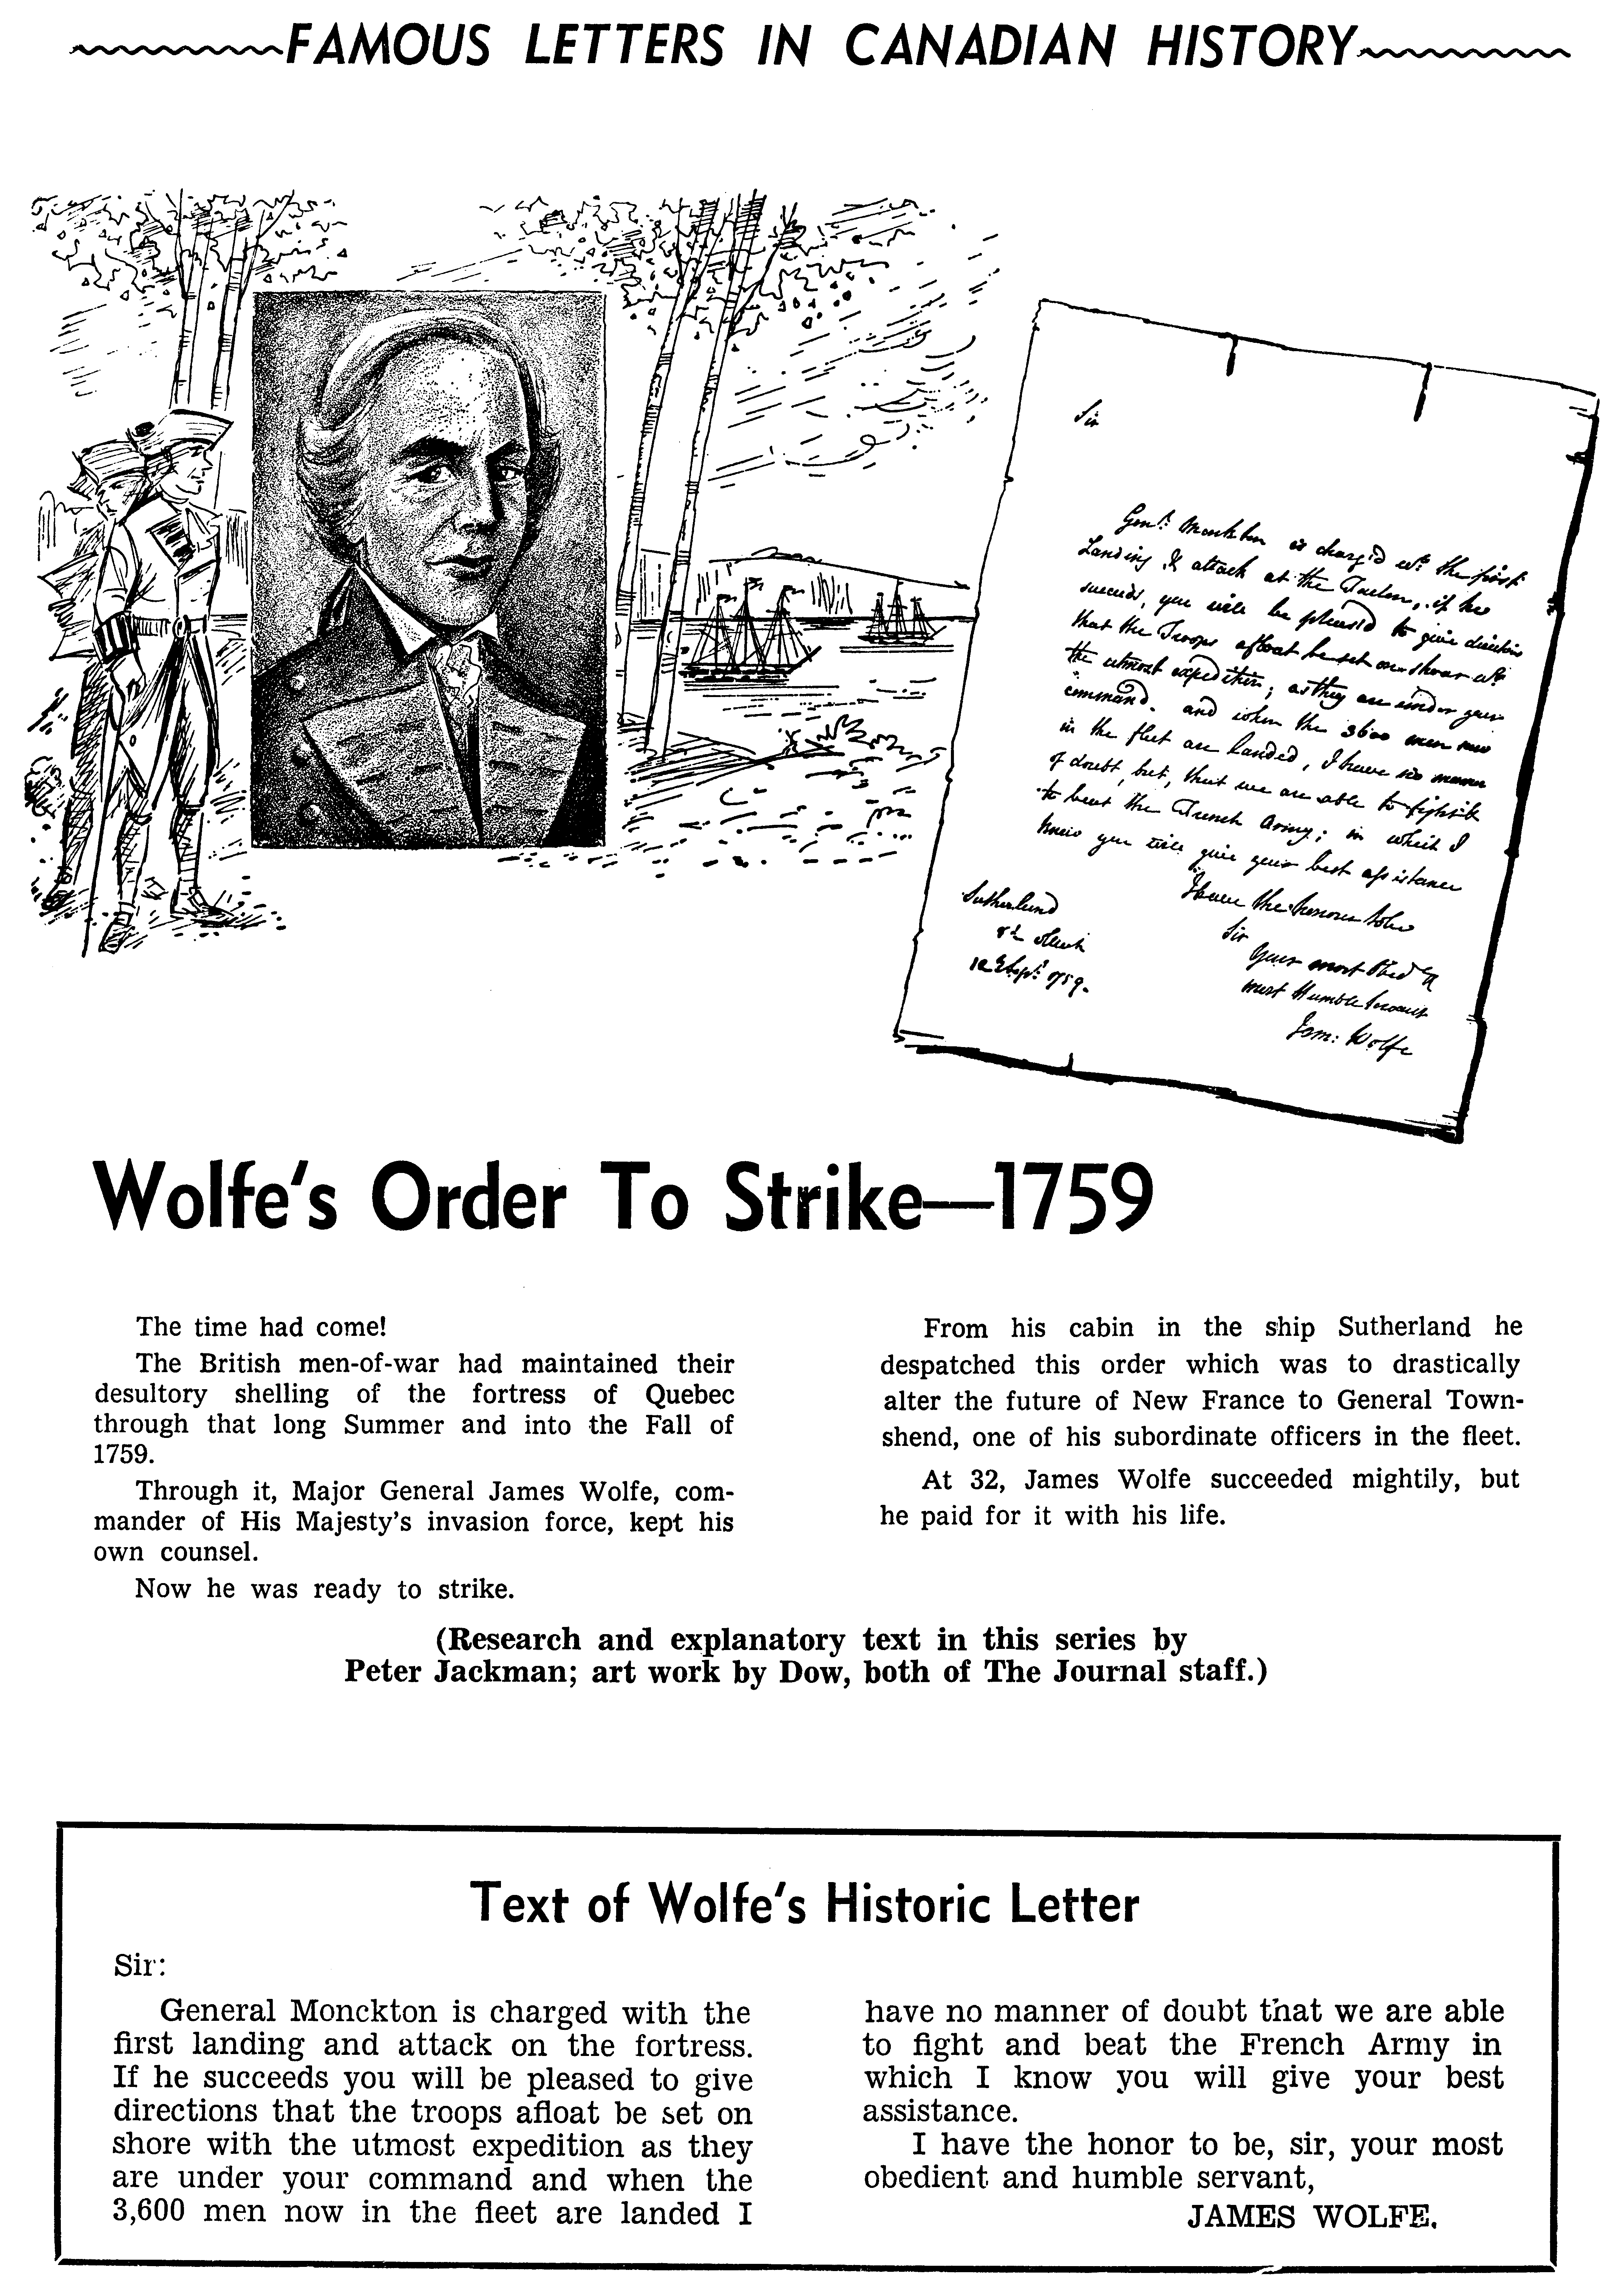
Reproduced from Famous Letters in Canadian History. Copyright 1964. Used by permission of Pat Jacobsen, on behalf of the late Peter Jackman.

