Background

Acadie was the name used for the Atlantic part of Nouvelle-France, an area that was first settled by the French at Port-Royal in 1605. It had no official boundaries, but included settlements in New Brunswick, Nova Scotia, and Prince Edward Island, where the descendants of French colonists lived and farmed for many generations. Living at some times under French rule, at some times under English rule, the Acadians came
to have a distinctive culture and way of life, and stayed neutral in
English–French conflicts.

In 1713, Acadie became a territory of England by the Treaty of Utrecht. The Acadians repeatedly refused to pledge allegiance to the monarch of England. Finally, in 1755, a royal decree ordered that they be deported from their lands and taken away to France or to French colonies.

Henry Wadsworth Longfellow, an American poet, wrote a romantic poem called Evangeline, about the separation of two Acadian lovers during this deportation. In this part of the poem, he describes life in the Acadian village of Grand-Pré, where the girl Evangeline lived.

As you read the poem, look for all the details that tell you what daily life was like in Acadie, and note them in your own words.

(page 1 of 2)

Part the First – I
In the Acadian land, on the shores of the Basin of Minas,
Distant, secluded, still, the little village of Grand-Pré
Lay in the fruitful valley. Vast meadows stretched to the eastward,
Giving the village its name, and pasture to flocks without number.
Dikes, that the hands of the farmers had raised with labor incessant,
Shut out the turbulent tides; but at stated seasons the flood-gates
Opened, and welcomed the sea to wander at will o'er the meadows.
West and south there were fields of flax, and orchards and cornfields
Spreading afar and unfenced o'er the plain; and away to the northward
Blomidon rose, and the forests old, and aloft on the mountains
Sea-fogs pitched their tents, and mists from the mighty Atlantic
Looked on the happy valley, but ne'er from their station descended
There, in the midst of its farms, reposed the Acadian village.
Strongly built were the houses, with frames of oak and of hemlock,
Such as the peasants of Normandy built in the reign of the Henries.
Thatched were the roofs, with dormer-windows; and gables projecting
Over the basement below protected and shaded the doorway.
There in the tranquil evenings of summer, when brightly the sunset
Lighted the village street and gilded the vanes on the chimneys,
Matrons and maidens sat in snow-white caps and in kirtles
Scarlet and blue and green, with distaffs spinning the golden
Flax for the gossiping looms, whose noisy shuttles within doors
Mingled their sound with the whir of the wheels and the songs of the maidens,
Solemnly down the street came the parish priest, and the children
Paused in their play to kiss the hand he extended to bless them.

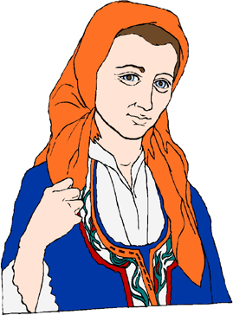
Evangeline, A Tale of Acadie, by Henry Wadsworth Longfellow (1847). Public domain.
(page 2 of 2)

