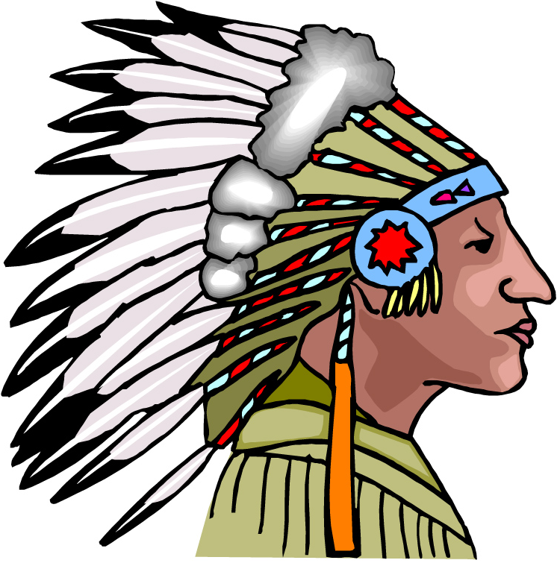
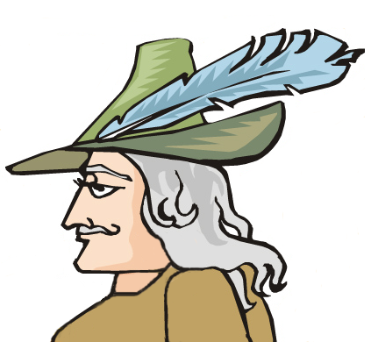
Based on your study so far this year of First Peoples
cultures, of European explorers and early settlement in Canada, fill in the chart below indicating all the things that each of these two cultures had to offer one another.

 | First Peoples | Europeans
Goods for Trade
Skills and Knowledge
Ways of Life and Values
Protection and Power

