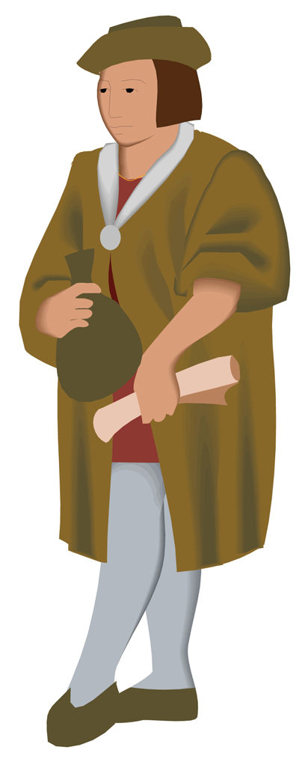
1. Black Robes: Récollet and Jesuit missionaries
2. Ursulines
3. Representatives of the Royal government
4. Seigneurs (landowners)
5. Habitants (men, women, and children)
5. Filles du Roi (Daughters of the King)
6. Huron (Wendat) Alliance, including the Montagnais and Algonquins
7. Iroquois (Haudensaunee)
8. Fur Traders and Merchants

Gather together with the people assigned to your group. Using the point of view of your assigned group of people, decide which were the two most important events in the history of early Nouvelle-France from 1603 to the 1740s. Refer to your notes, web sources, textbooks, and other references to help you decide.

Our group represents: _____________________________________________

The two most important events in this period are:

1. ______________________________________________________________

2. ______________________________________________________________

Our reasons are:
______________________________________________________________

______________________________________________________________

______________________________________________________________

______________________________________________________________

______________________________________________________________

______________________________________________________________

