Create a poster promoting the search for the Northwest Passage. Include illustrations, clip art, and maps to show how the keywords listed below relate to the search for the Northwest Passage.

Keywords

trade routes
Europe
Asia
world influence
Spain
England

France

Portugal
China
silk
spices
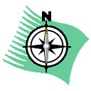

overland route
explorers

navigation
sailing ships
empires
India
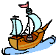

America
adventure
mapping
oceans

