The following excerpts are from a translation of journals kept by Jacques Cartier and his crew to document his voyages to the land that was to become Nouvelle-France.

Early September 1535
On September the first we set sail from this harbour to make our way toward Canada. Some fifteen leagues to the west-southwest of this harbour, in the middle of the stream, lie three islands, and opposite to them there is a very deep and rapid river, which is the river and route to the kingdom and country of the Saguenay, as we were informed by our two men from Canada. This river issues from between lofty mountains of bare rock with but little soil upon them. Notwithstanding this, a large number of various kinds of trees grow upon this naked rock as in good soil, in such sort that we saw rather a tree tall enough to make a mast for a ship of thirty tons, which was as green as possible, and grew out of the rock without any trace of earth about it. At the mouth of the river we found four canoes from Canada that has come there to fish for seals and other fish. And when we had anchored in that river, two of the canoes came toward our ships but in such fear and trembling that one of them finally went back…

The next morning, we made sail and got underway in order to push forward, and discovered a species of fish, which none of us had ever seen or heard of. The fish is as grey as a porpoise and has no fin. It is very similar to a greyhound about its body and head and is as white as now, without a spot on it. Of these there are a very large number in this river, living between the salt and the fresh water. The people of this country call them Adhothuys and told us they are very good to eat. They also informed us that these fish are found nowhere else in all this river and country except at this spot.

Later in the fall of 1535
…And we went some ten leagues up the river, coasting this island [of Orleans], at the end of which we came to a forking of the waters, which is an exceedingly pleasant spot, where there is a small river and a harbour with a bar, on which at high tide, there is a depth from two to three fathoms. We thought this river
[St. Charles] a suitable place in which to lay up our ships in safety. We named it
Ste Croix…

(page 1 of 2)
Near this spot lives a people of which this Donnacona is leader, and he himself resides there. The village is called Stadacona. This region is as fine a land as it is possible to see, being very fertile and covered with magnificent trees of the same varieties as in France, such as oaks, elms, ash, walnut, plum-trees, yew-trees, cedars, vines, hawthorns, bearing a fruit as large as a damson, and other varieties of trees. Beneath these grows as good hemp as that of France, which comes up without sowing or tilling it.

October 1535
On issuing forth from the village [Hochelaga] we were conducted by several of the men and women of the place up the above-mentioned mountain, lying a quarter of the league away, which was named by us “Mount Royal”. On reaching the summit we had a view of the land for more than thirty leagues round about. Towards the north there is a range of mountains, running east and west, and another range to the south. Between these ranges lies the finest land it is possible to see, being arable, level, and flat. And in the midst of this flat region one saw the river [St. Lawrence] extending beyond the sport where we hade left our longboats. At that point there is the most violent rapid it is possible to see, which we were unable to pass. And as far as the eye can reach, one sees that river, large, wide, and broad, which came from the southwest and flowed near three fine conical mountains, which we estimated to be some fifteen leagues away. And it was told us and made clear by signs by our three local guides that there were three more such rapids in that river, like the ones where lay our longboats; but through lack of an interpreter we could not make out what the distance was from one to the other.
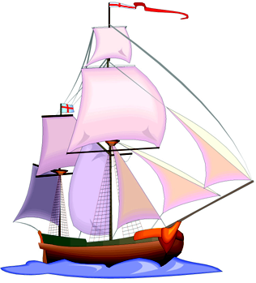

Reprinted with permission of Library and Archives Canada from Biggar, H.P., ed. The Voyages of Jacques Cartier. Ottawa, ON: FA Acland; 1924. Publications of the Public Archives of Canada, No. 11.
(page 2 of 2)

