Research the First Peoples in the main regions described below. What were the main traditional ways of life of these people in early times: hunting, gathering, fishing or farming? In the last column, write a question you want to explore about the connection of these peoples to their territories.

Cultural Region | Location | First Peoples | Traditional Ways of Life | Questions
Eastern Woodlands |  | 1.  2.
Subarctic Woodlands |  | 1.  2.
Plains |  | 1.  2.
Arctic |  | 1.  2.
Western Plateau |  | 1.  2.
Northwest Coast |  | 1.  2.
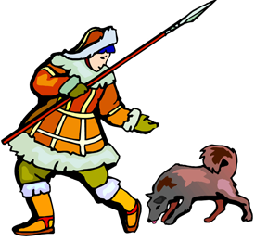
Names of some First Peoples:
Blackfoot (Siksika) Salish
Tlingit Ojibway
Mohawk Algonquin
Nisga’a Assiniboine
Inuit Iroquois
Haida Innu
Mi’kmaq Huron (Wendat)
Kootenay Thule
Sioux (Dakota) Dene
Beothuk
Cree (Plains, Woodlands)
Swampy Cree (Omushkego)
