Use the following web to organize your information about a region (or part) of the land on which First Peoples lived.
Imagine you are living in pre-contact times. In which region would you prefer to live?

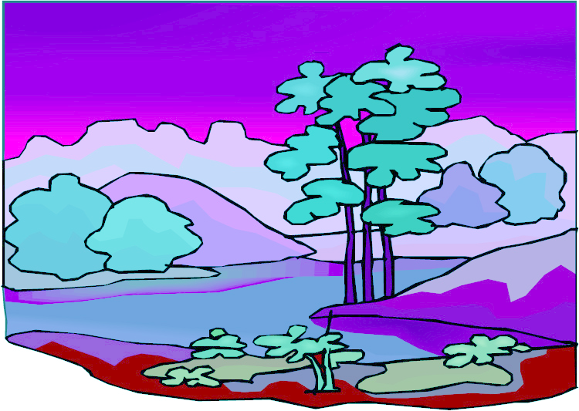
Name some important bodies of water in or around this region.
Describe the landforms (mountains, plains, etc.) of this region.
What types of vegetation grow here?
Describe this land using traditional terms.
Describe the climate and the seasons.
Name the animals that live here.
How could people live on the land in this region?
Describe how to locate this region in today’s terms.

