Pacific Ocean | Atlantic Ocean | Arctic Ocean
Great Bear Lake | Peace River | Red River
Assiniboine River | Lake Manitoba | Lake Michigan
Lake Huron | James Bay | Ottawa River
Churchill River | Lake Winnipeg | Mackenzie River
St. Lawrence River | Lake Erie | Nelson River
Lake Ontario | Georgian Bay | Hudson Bay
Saskatchewan River | Fraser River | Great Slave Lake
Lake Superior | Lake Athabasca | Add one river or lake:
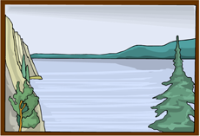
Place two check marks () in each box for each body of water correctly identified on the map without consulting an atlas. Place one check mark () in each box for each body of water identified using an atlas.

