Choose the location on the map where you would like to settle.  Explain your choice.  Keep in mind, this is long ago, before cities and roads were developed. | 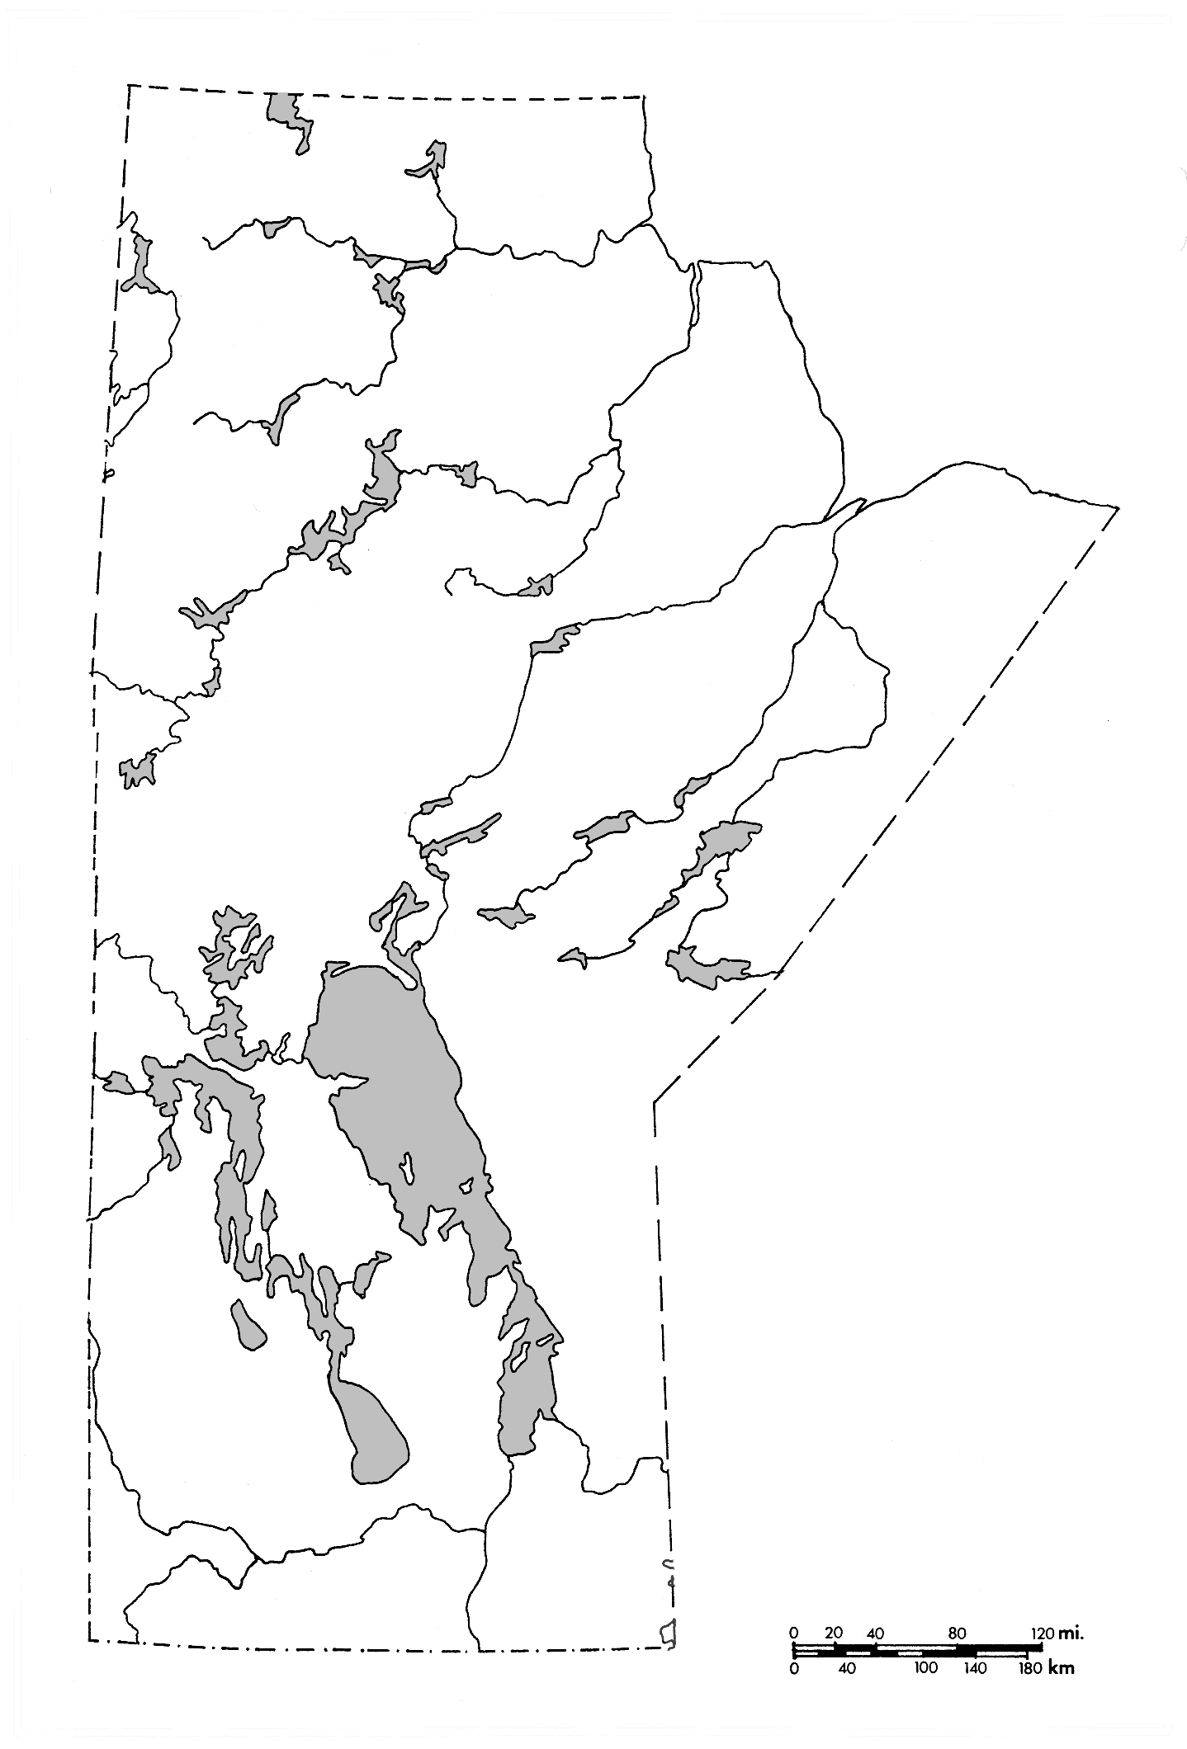 | 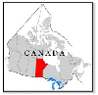

I chose this location because

