Identify challenges and opportunities settlers might encounter in each location related to the natural environment and/or interactions with Aboriginal peoples.  *  *  *  *  * | 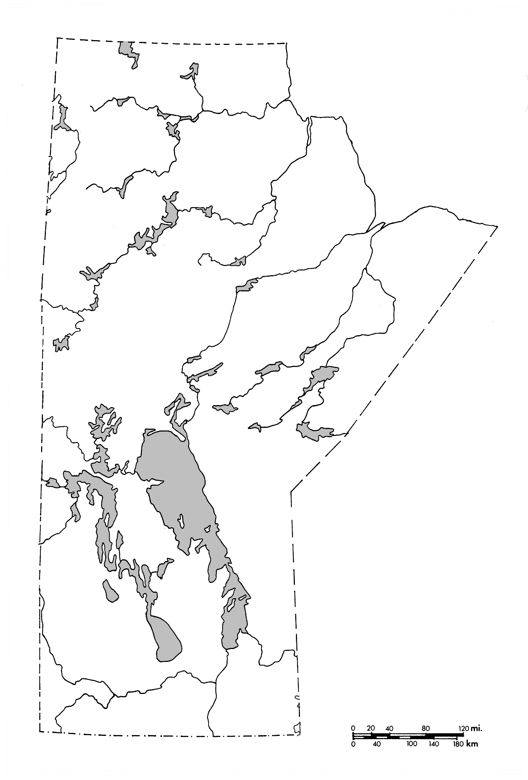 | 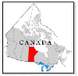

Challenges and Opportunities
Location # 1

Location # 2

Location # 3

Location # 4

Location # 5

