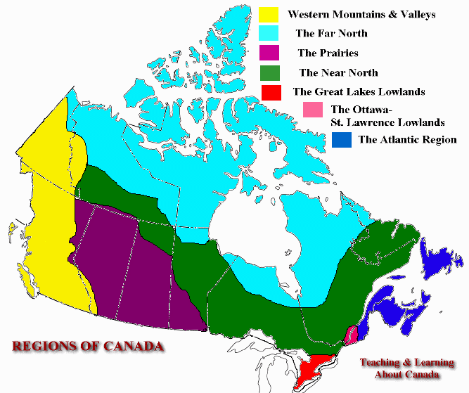
The Atlantic Region
The Ottawa-St. Lawrence Lowlands
Western Mountains & Valleys
The Far North
The Prairies
The Near North
The Great Lakes Lowlands
REGIONS OF CANADA
Teaching & Learning About Canada

