Colour Canada on the world map below. Place a small star * on two communities or countries you would like to visit, and label their names. Describe how you would travel to each community (e.g., air, water, land), predict how long it might take to get there, and describe what you might see when you arrive.

3.3.1
a
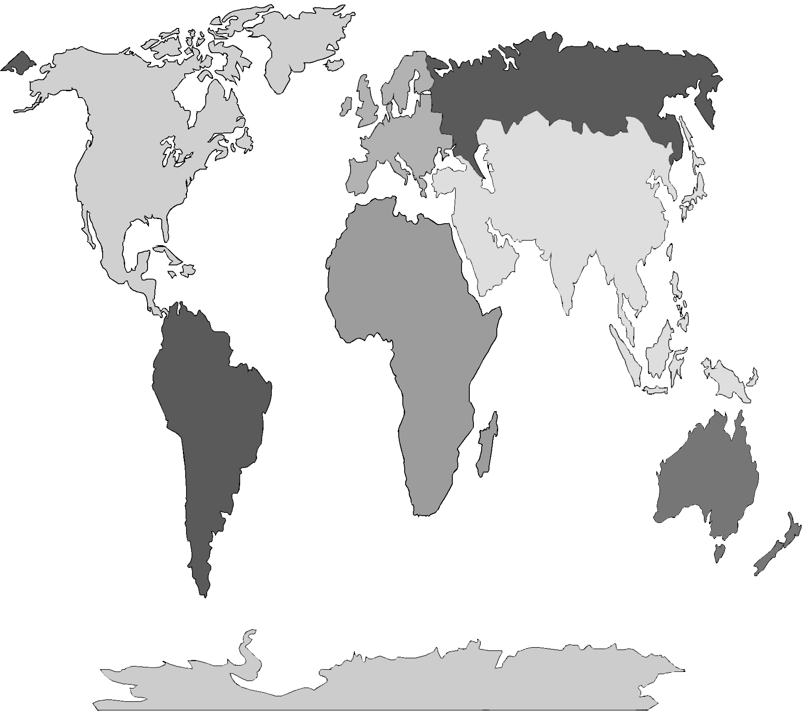

1 of 2

