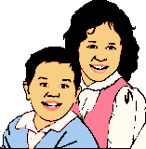
Water
Shelter
Health
Food
Clothing

