Decide if each word is a need or a want, and write it in the correct column.

basketball
bed
bike
candy
car
clothing
computer
doll
food
game
horse
love
money
safety
shelter
sunglasses
telephone
toys
vacation
water

Needs | 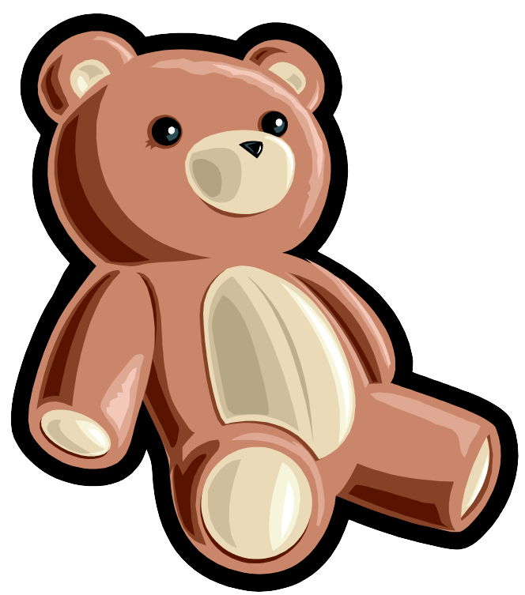  Wants

