CANOES – Canoes made of bark and pitch varied greatly in size, depending on what they were needed for. Today’s recreational canoe is fashioned after this Aboriginal invention, and it, along with the kayak, is unsurpassed throughout the world for travelling over shallow or difficult waterways. | UPSET STOMACH REMEDIES – A tea made with the entire blackberry plant was used for a number of sicknesses, including dysentery, cholera, and upset stomach. Eating the actual berry or drinking its juice was also an effective way to control diarrhea. | CORN – Corn is a staple food that was cultivated by Aboriginal people for thousands of years. Today, corn is a vital, hardy, and high-yielding plant that can grow practically everywhere in the world.
DART GAME – Some Aboriginal people created the game of lawn darts, using shucked new green corn with its kernels removed. Feathers were attached to the darts, which were tossed at targets on the ground. | PETROLEUM JELLY – Aboriginal people discovered petroleum jelly and used it to moisten and protect animal and human skin. It was also used to stimulate healing. This skin ointment is one of the most popular in the world today. | LACROSSE – Aboriginal people played hundreds of outdoor team sports. Lacrosse is a team sport invented by Aboriginal people, which many believe is the forerunner to hockey.
SNOWSHOES – Aboriginal people developed technology for travel over snow. Many kinds of snowshoes were developed by Aboriginal people. A very common style was made from spruce and rawhide thongs. | WILD RICE – Wild rice is actually a delicious and prized cereal grain. It was misnamed by European newcomers because of its rice-like appearance. Some Aboriginal people presented wild rice as treasured gifts to fur traders as a symbol of friendship. | COUGH SYRUP – Many Aboriginal people throughout Canada developed unique combinations of wild plants to relieve coughs due to colds. The same ingredients are found in many cough medicines sold today. The balsam of various pine trees, maple syrup, or honey, are mixed with teas made from healing plants to produce very effective cough medicines.
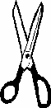

(page 1 of 4)

SNOW GOGGLES – Northern Aboriginal people developed bone, antler, and ivory goggles to prevent blinding snow glare while they hunted. | CURE FOR SCURVY – Aboriginal people shared their cure for scurvy with European newcomers. The bark and needles of an evergreen tree such as hemlock or pine were boiled to make a vitamin C-rich tonic, which scurvy sufferers drank. | CHEWING GUM – Aboriginal people discovered the first chewing gum, which was collected from spruce trees. In the 1800s, sugar was added, and chewing gum has since become popular throughout the world.
PAIN RELIEF – The active ingredient in today’s most commonly used pain reliever was known to Aboriginal people in North American for centuries. Pain relievers such as Aspirin™ use an acid, which is found in 15 to 20 different species of the willow tree, including the pussy willow. | SUNFLOWERS – Sunflowers are native to North America and were important sources of nutrition for the original inhabitants. Today, growers harvest sunflowers for their seeds in Canada, the United States, Europe, and parts of Asia and South America. Sunflower seeds are popular snacks today because they are tasty, healthy, and nutritious. | TOBOGGAN – The Mi’kmaq people of eastern Canada invented the toboggan, or taba’gan to use the Mi’kmaq word. Toboggans were first made of bark and animal skins. By the year 1600, Mi’kmaq toboggans were made of thin boards, curved at the front. They were ideal for hauling game out of the woods, moving camp, and for travel. Many winter sports have grown out of this original invention, including luge and bobsledding.
KAYAK – Kayaking started thousands of years ago in the Arctic regions of what we now call Greenland, Siberia, and North America. Inuit, the original people of the Canadian Far North, used the kayak to travel, to fish, and to hunt large sea mammals, seals, and even caribou. Today, the sport of kayaking is loved worldwide.
Reproduced with permission from First Nations and Inuit Contributions and Inventions Colouring Book, published under the authority of the Minister of Indian Affairs and Northern Development, Ottawa, 1998.
(page 2 of 4)

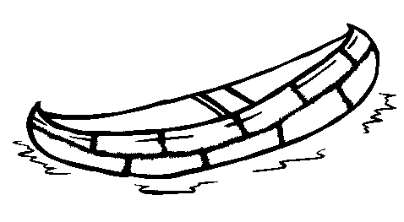 | 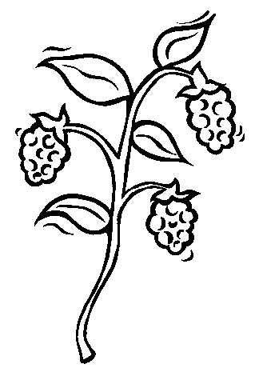 | 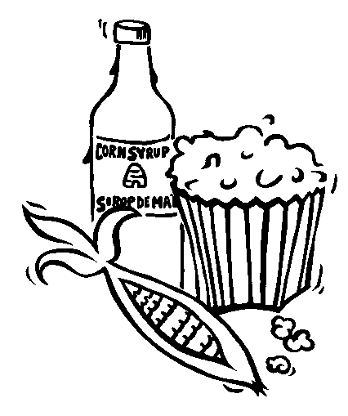
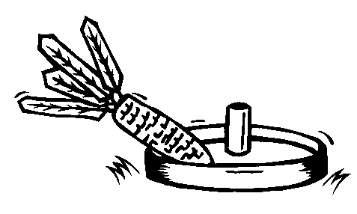 | 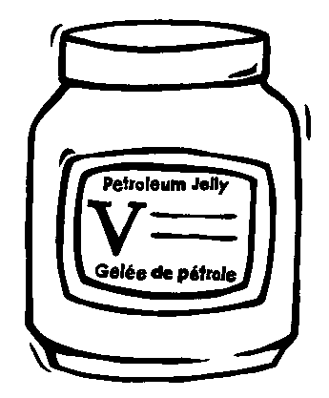 | 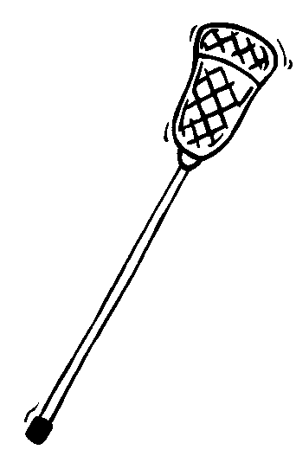
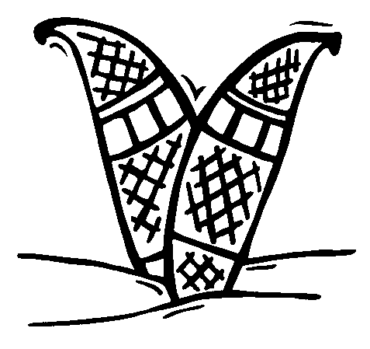 | 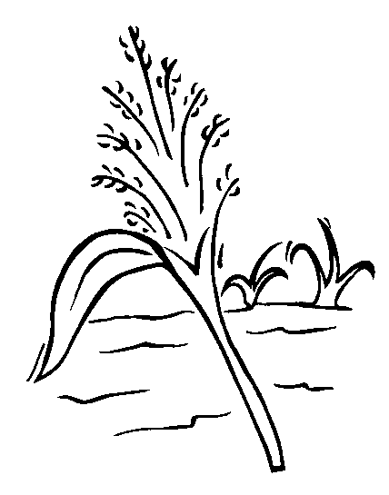 | 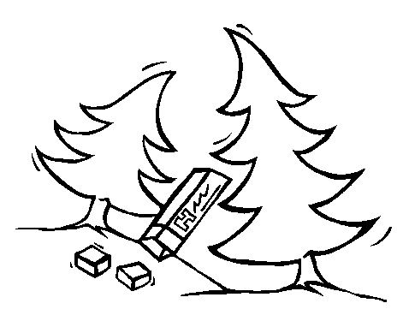

(page 3 of 4)
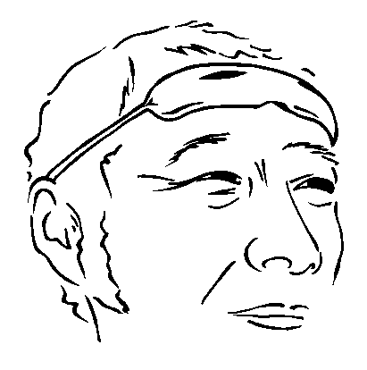 | 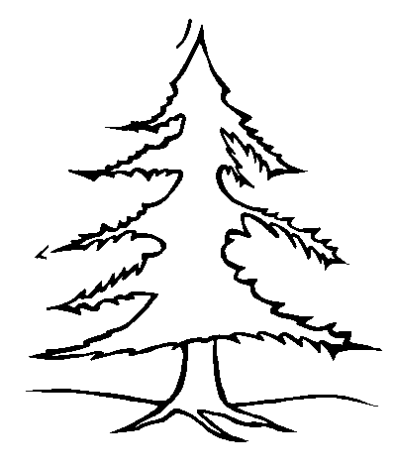 | 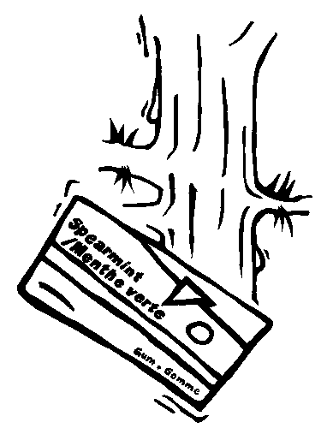
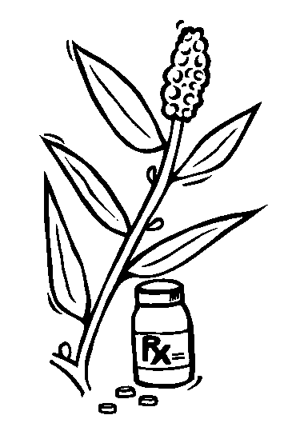 | 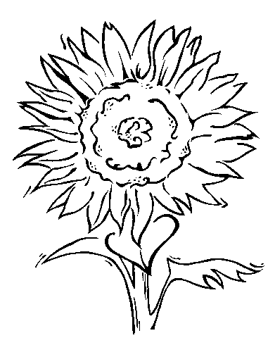 | 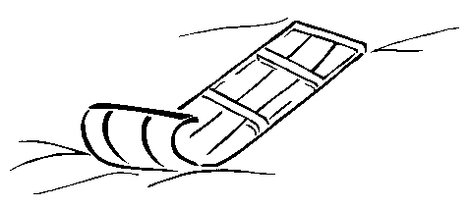
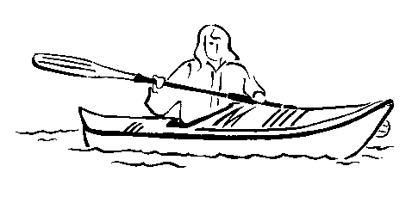
Reproduced with permission from First Nations and Inuit Contributions and Inventions Colouring Book, published under the authority of the Minister of Indian Affairs and Northern Development, Ottawa, 1998.
(page 4 of 4)

