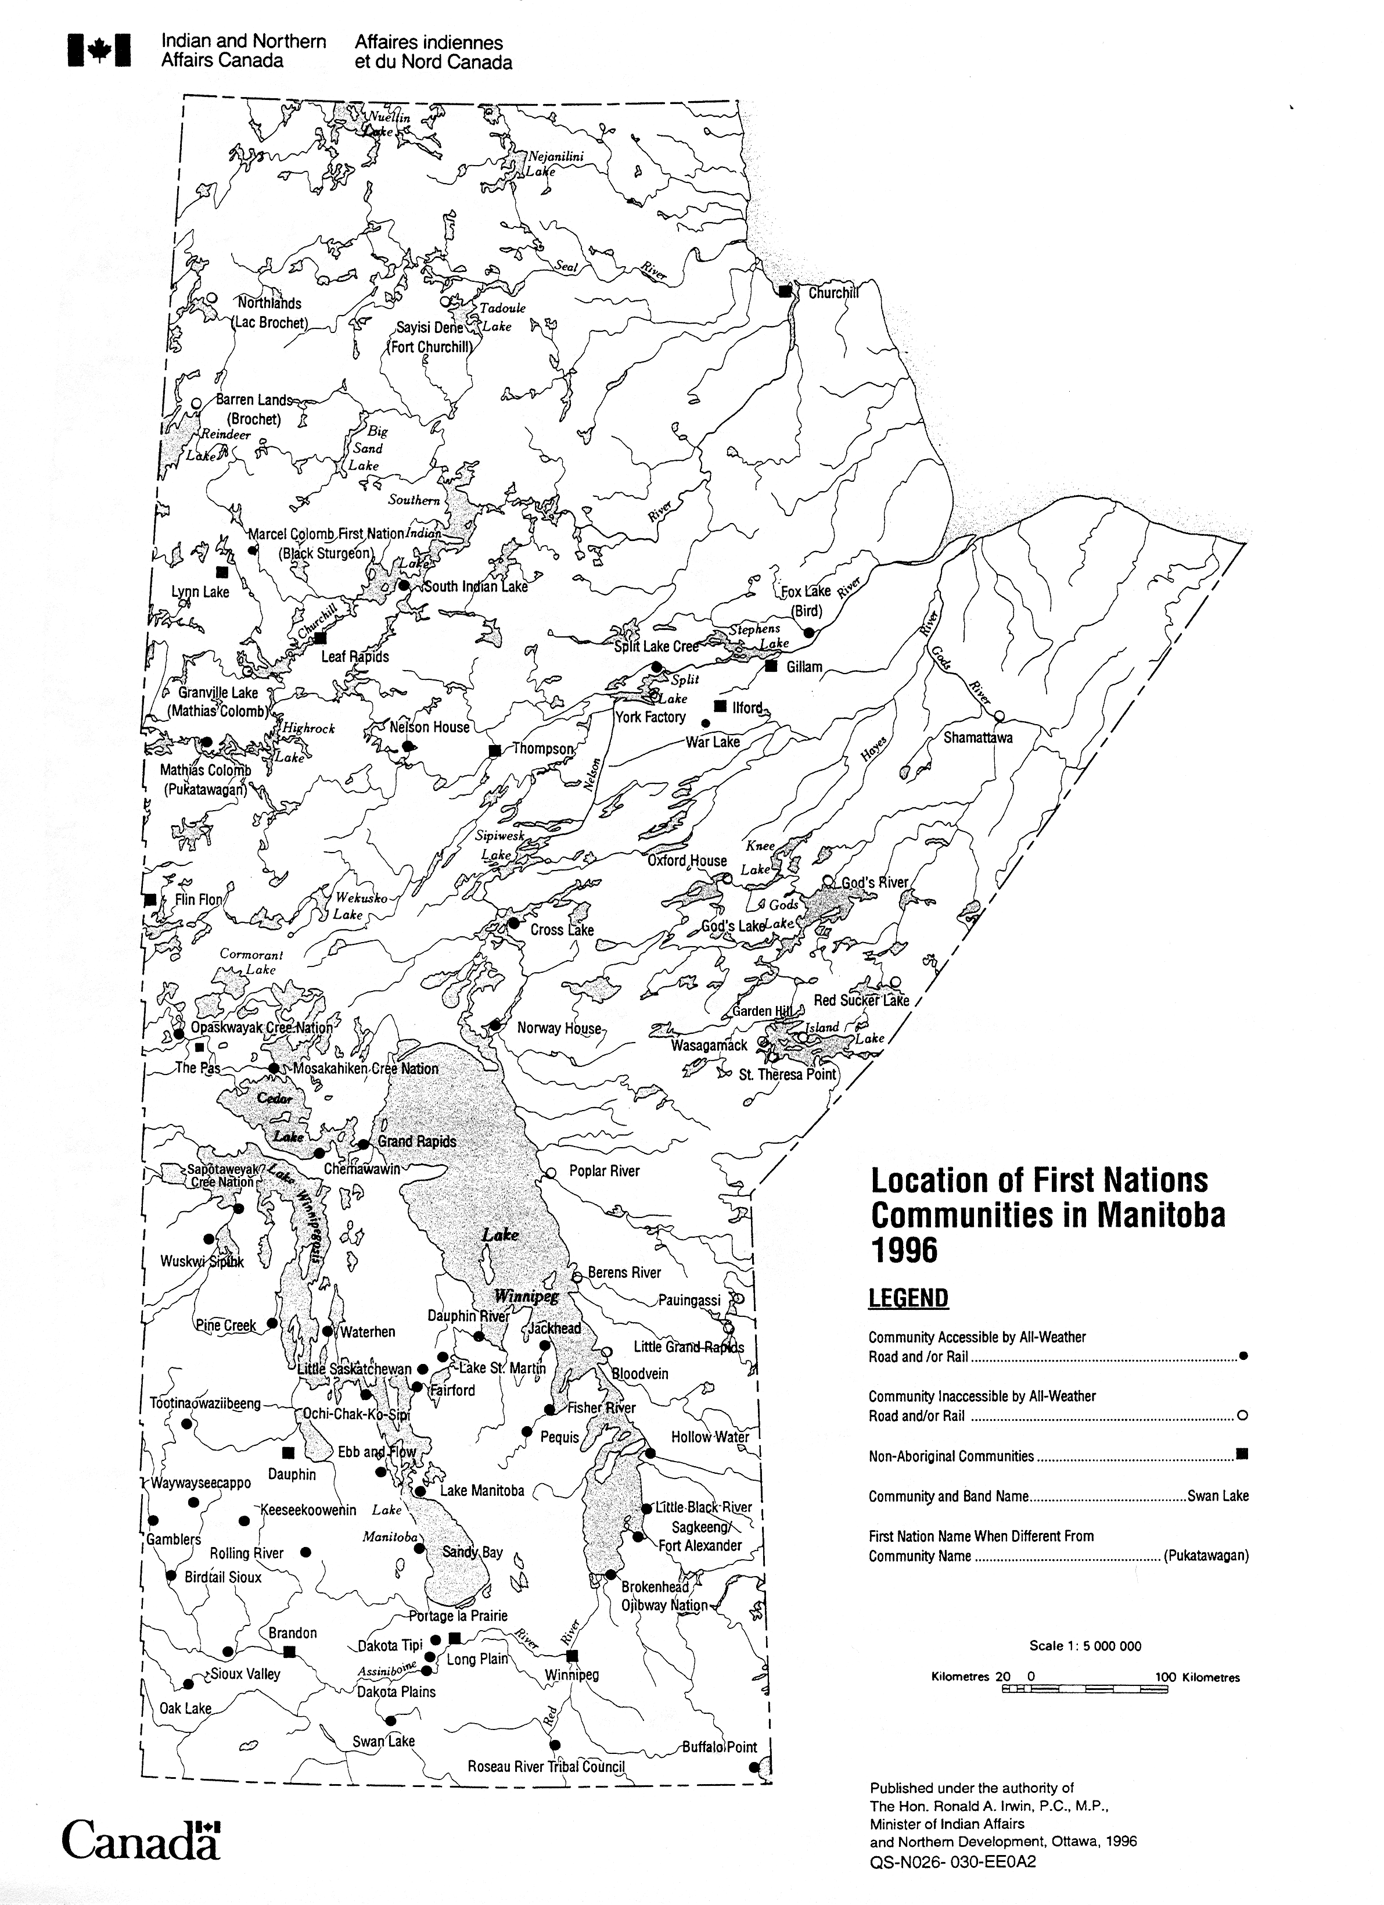
_________
Reproduced from First Nations Community Profiles 1997-98 with permission from Indian and Northern Affairs Canada (INAC). All rights reserved.

