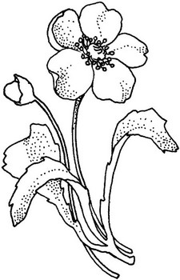  Poppy | Cross
Dove | Cenotaph

Remembrance Day is important because...

