1. Colour the province of Manitoba.
2. Colour the rest of Canada a different colour.
3. Draw a star at your community.
4. Colour the water blue.
5. Place the words Canada and Manitoba on the map.
6. Fill in the correct words in the sentences.

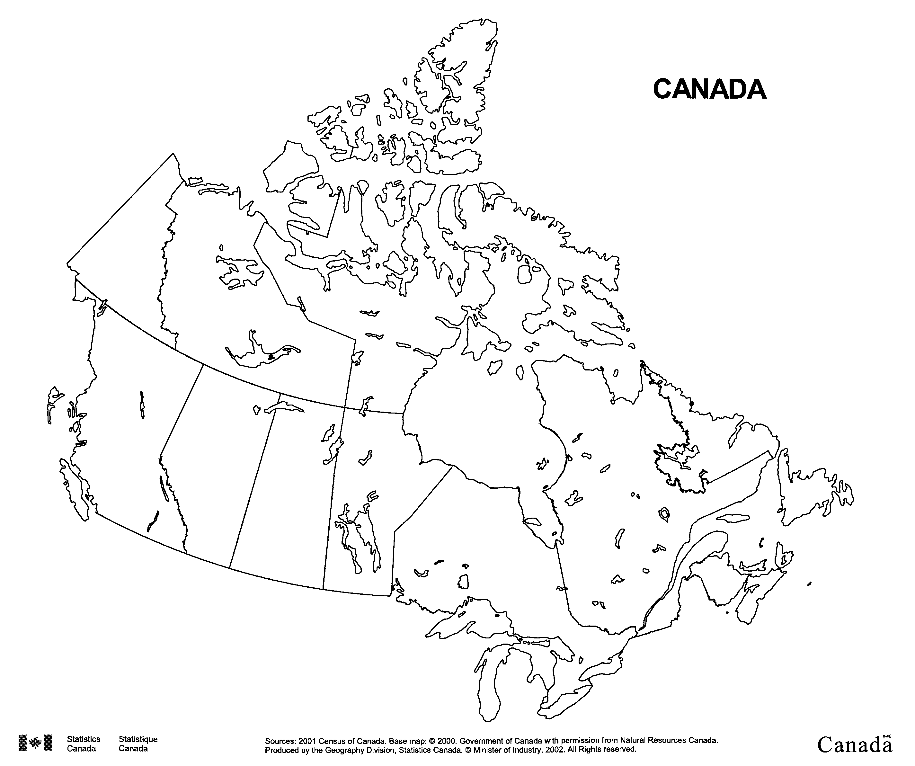

My country is called __________________________________________.

I live in the province of ________________________________________.

The name of my community is ____________________________________.

The two official languages of Canada are

___________________________ and ___________________________.

We speak these languages in my community__________________________

__________________________________________________________

