Lesson 4: Sexuality Influences and Supports

Cluster of Learning Outcomes
Students will…
 K.5.S2.E.3a Examine sexuality as it is portrayed in the media (e.g., fashion magazines, music videos, advertisements, movies, songs…).
 K.5.S1.E.3b → K.5.S2.E.3b Examine the influences (e.g., family values, culture and religion, peer pressure, media images and advertising, substance use…) on making decisions for responsible sexual behaviour.
 K.5.S1.E.3c → K.5.S2.E.3c Review personal responsibilities and sources of support (e.g., parents, nurses, doctors, counsellors, helplines, community health services, religious leaders, recommended books…) with regard to sex-related health issues.
K.4.S2.A.3 Analyze factors (i.e., values, beliefs, peers, media, environment, finances) that influence personal and/or group decisions for active, healthy lifestyles.
K.4.S2.C.2 Describe situations (e.g., presentations, competitions, tests, new situations, family conflicts, time constraints, media influences, peer pressure, relationships, financial difficulty, academic expectations, physical features, technology, emergencies…) that cause personal stress.
 Indicates targeted learning outcomes.

Lesson Focus
As a result of the learning activities within this lesson students will be able to
• define sexuality
• record the impact of observed media messages regarding sexuality
• analyze a specific media message portraying sexuality
• identify influences on responsible sexual behaviour
• analyze relationship scenarios
• identify sources of support for sex-related health issues

Resources

Blackline Master
• BLM S2-4.1: Media Messages about Sexuality
General Blackline Master (See Appendix B)
• BLM G-10: Sexual Health Information and Crisis Lines for Youth
Resource Master (See Appendix C)
• RM 1: Pressures on Sexual Decision Making
Print/Publications
• Aboriginal Nurses Association of Canada and Planned Parenthood Federation of Canada.
Finding Our Way: A Sexual and Reproductive Health Sourcebook for Aboriginal Communities. Ottawa, ON: Aboriginal Nurses Association of Canada and Planned Parenthood Federation of Canada, 2002.
• Planned Parenthood Federation of Canada. Beyond the Basics: A Sourcebook on Sexual and
Reproductive Health Education. Ottawa, ON: Planned Parenthood Federation of Canada, 2001. Available online at: <http://www.ppfc.ca>.
Organization/Website
• Sexuality Education Resource Centre (SERC), Manitoba: <http://www.serc.mb.ca/>


Notes to Teacher
Be sensitive to different cultural perspectives on reproductive health.

For sources of support, consult Sexuality Education Resource Centre (SERC): <http://www.serc.mb.ca/>. Refer to SERC for a list of Winnipeg clinics and for information regarding reproductive health supports across Manitoba.

Curricular Connections
PE/HE:
K.5.S1.E.3b
K.5.S1.E.3c

Suggestions for Instruction

1. Definition of Human Sexuality
Have students brainstorm for a definition of human sexuality.
Example:
Human sexuality describes the way people choose to experience and express themselves as sexual creatures, and involves biological, psychological, social, economic, political, cultural, ethical, legal, historical, religious, and spiritual factors; it encompasses the sexual knowledge, attitudes, values, beliefs, and behaviours of individuals within a culture (World Health Organization; Health Canada, Canadian Guidelines for Sexual Health Education, 4).
2. First Impressions
Students collect pictures (from various media) portraying sexuality in society. They write down their impressions of each picture, indicating
• what effect the picture has on them
• what message it is trying to convey
Encourage class discussion.
3. Media Messages
In groups of three or four, students select and examine a media message (e.g., video clip, magazine advertisement, song) on human sexuality, using as a guide the BLM provided.

Refer to BLM S2-4.1: Media Messages
about Sexuality.
Groups present their conclusions and information to classmates. Encourage class discussion.
4. Circle of Influences
Lead a class discussion in which students identify and examine the influences related to making decisions for responsible sexual behaviour. Students record “major” influences in pen and “minor” influences in pencil.
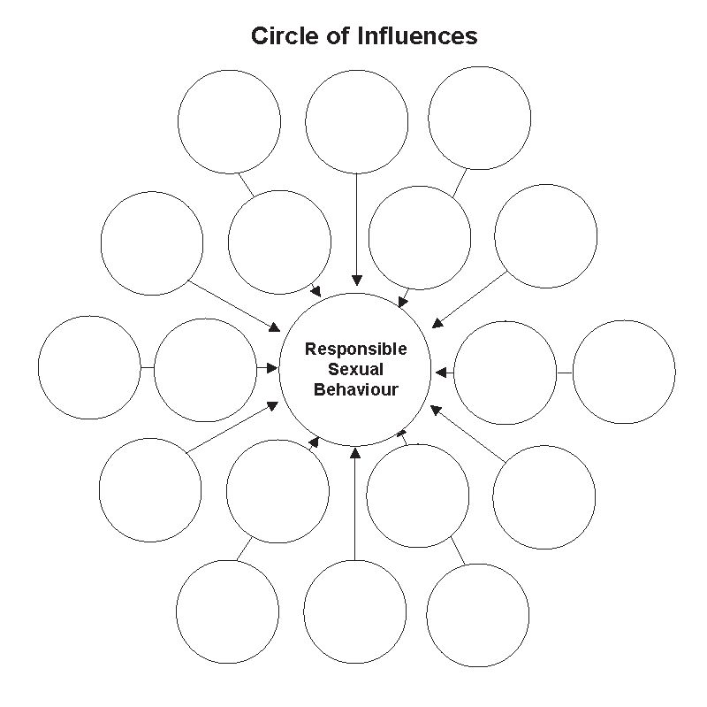
Influences may include
• family/parental values
• personal values
• health beliefs
• culture
• religion
• peer pressure
• media images
• advertising
• substance use
• STIs
• unplanned pregnancy
• other

5. Relationship Decisions
To help students identify specific influences (pressures) that affect responsible decisions regarding sexual behaviour, arrange students in four groups and assign one of the suggested relationship scenarios to each group.
Each group discusses their relationship scenario and identifies
• the alternative ways their scenario could be acted out
• the influences that affected the alternative outcomes
• the positive/negative consequences of each alternative
Groups share their discussions with the class.
Suggested Scenarios:
a. Paul and Carrie have been seeing each other for a long time, and lately they have both found it difficult to control their sexual feelings for each other. While Carrie has “promised” herself not to engage in sex until she is older, and Paul has respected her request, they have discussed what a great opportunity they would have spending some intimate time together at the upcoming all-night party at the home of one of their friends, whose parents will be out of town for the weekend. Paul has told Carrie he will bring along some beer.
b. Evan and several of his friends are at a party. During a dance, Jill lets Evan know she wants him to come to her place to “have sex” since no one is home. While all Evan’s friends think he should go, Evan doesn’t particularly want to have sex with her.
c. Sandy and Lee have been dating for a year, and both feel they are not ready for a “sexual” relationship. Lately Lee’s friends are asking a lot of questions about his/her sex life with Sandy.
d. Cory and Pat have been dating casually for weeks. Cory would like it to be a committed and intimate relationship. Pat’s parents don’t approve of Cory and don’t want Pat to be “tied down.”
6. Support Centre
Working in groups of three or four, students create and name their own resource centre for sex-related health issues. Groups identify a minimum of five sources of support and explain the services that would be offered. Groups present information to the class.
Distribute copies of BLM G-10: Sexual Health
Information and Crisis Lines for Youth.

Suggestions for Assessment

Journal/Learning Log: Media Messages
Teacher Assessment: Anecdotal Notes
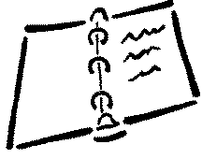
Students respond, in their journals/learning logs, to the following questions regarding their selected media message portraying sexuality:
1. Why are media messages so important/powerful?
2. Does your media message appeal to your emotions or to your sense of reason/judgement?
3. Does your media message affect your opinion of what is acceptable, normal, and healthy?
4. What is the message in your media example?
5. What is the hidden/unspoken message in your media example?
Journal/Learning Log: Circle of Influences
Self-Assessment: Inventory
Students respond to the following statement
in their journals/learning logs:
There are many influences (major and minor) that affect a person’s decision making for responsible sexual behaviour. Choose at least three of the influences and explain which would be a major or minor influence for you.
Journal/Learning Log: Relationship Decisions
Self-Assessment: Inventory
Students reflect, in their journals/learning logs,
on the following:
1. Write about a situation (real or fictional) in which your decision regarding sexual behaviour was influenced by certain factors.
2. Identify the factors and their effects, examining whether or not the decision regarding sexual behaviour was a responsible one.
Performance Task: Support Centre
Teacher Assessment: Checklist
Assess the presentation of each group, using a checklist.
Group Presentation Checklist
The group | Yes | No | Comments
- identifies five sources of support offered
by the centre
- explains the nature of the services provided

Notes

