Lesson 3: Healthy Pregnancy

Cluster of Learning Outcomes
Students will…
 K.5.S2.E.1c Describe the importance of and conditions for a healthy pregnancy (e.g., avoidance of alcohol and tobacco, proper nutritional intake…).
K.4.S2.C.1a Describe the behaviours necessary for providing others with support (e.g., listen to a friend in difficulty…) and promoting emotional health and well-being.
 Indicates targeted learning outcome.

Lesson Focus
As a result of the learning activities within this lesson students will be able to
• list conditions necessary for a healthy pregnancy
• present evidence supporting the necessity of these conditions

Resources
Resource Masters (See Appendix C)
• RM 6: Fetal Circulation
• RM 7: Personal Care during Pregnancy
• RM 8: Pregnancy and Alcohol/Drugs
Print/Publication
• Manitoba Addictions Awareness Week (MAAW) Committee. Manitoba Addictions
Awareness Week: Resource Kit. Winnipeg, MB: MAAW Committee, current annual publication. Available from Addictions Foundation of Manitoba.
Organizations/Websites
• Addictions Foundation of Manitoba: <http://www.afm.mb.ca/>
• Health Canada: <http://www.hc-sc.gc.ca/>
Professionals
• Elder/religious leader
• guidance counsellor
• physician
• public health nurse

Notes to Teacher

Prior to class, read the following resource masters:
• RM 6: Fetal Circulation
• RM 7: Personal Care during Pregnancy
• RM 8: Pregnancy and Alcohol/Drugs
Information on substance abuse in pregnancy is available from the Addictions Foundation of Manitoba: <http://www.afm.mb.ca/>.
Current nutrition information is available from Health Canada: <http://www.hc-sc.gc.ca/>.

Curricular Connections
ELA:
GLO 3—Manage ideas and information
GLO 4—Enhance the clarity and artistry of communication

Suggestions for Instruction

1. Healthy Pregnancy Web
Students individually identify the conditions for a healthy pregnancy (e.g., avoid alcohol, smoking, and drugs, use safe sex methods, eat healthy foods, have medical checkups), recording their ideas in a web format such as the following. Students share their webs with a partner.
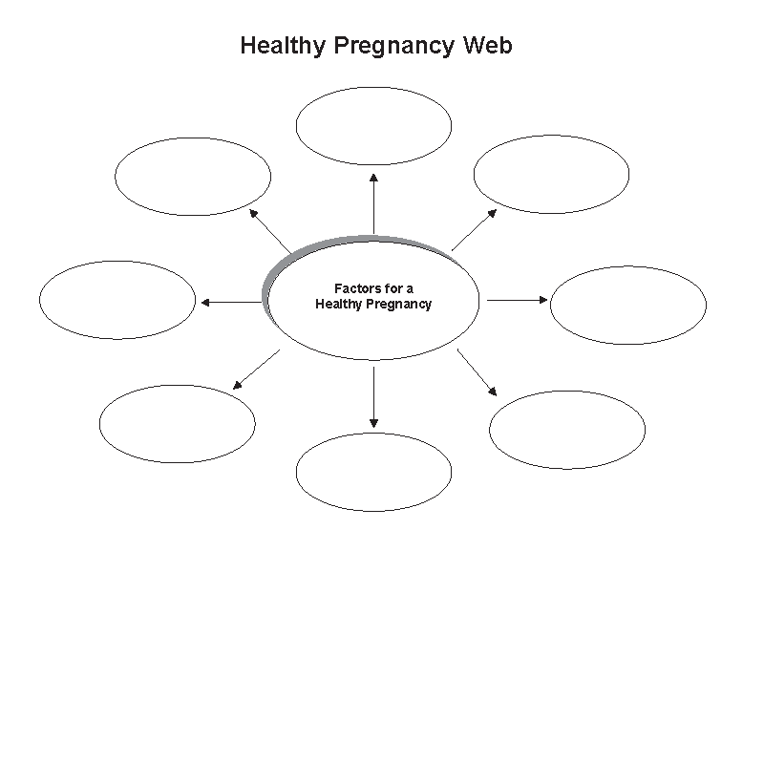

2. Healthy Pregnancy: Why It Matters
Working in groups of three or four, students select a condition identified on the Healthy Pregnancy Web, research its significance, and present their information to the class, noting evidence that supports the importance of the selected condition for a healthy pregnancy.


Suggestions for Assessment
Questioning/Interview: Healthy Pregnancy Web
Peer Assessment: Inventory
Students exchange their completed webs for a healthy pregnancy and discuss them with a peer.
Performance Task: Healthy Pregnancy: Why It Matters
Peer/Teacher Assessment: Rating Scale
Students assess group presentations using the following rating scale.
Group Presentation Rating Scale
Scale | The group identifies
A | - substantial evidence that supports the significance of a selected condition for a healthy pregnancy
B | - satisfactory evidence that supports the significance of a selected condition for a healthy pregnancy
C | - limited evidence that supports the significance of a selected condition for a healthy pregnancy
D | - very little or no evidence that supports the significance of a selected condition for a healthy pregnancy

Notes

