
Maternal and Fetal Circulation

K.5.S1.E.1c

BLM
S1-4.1

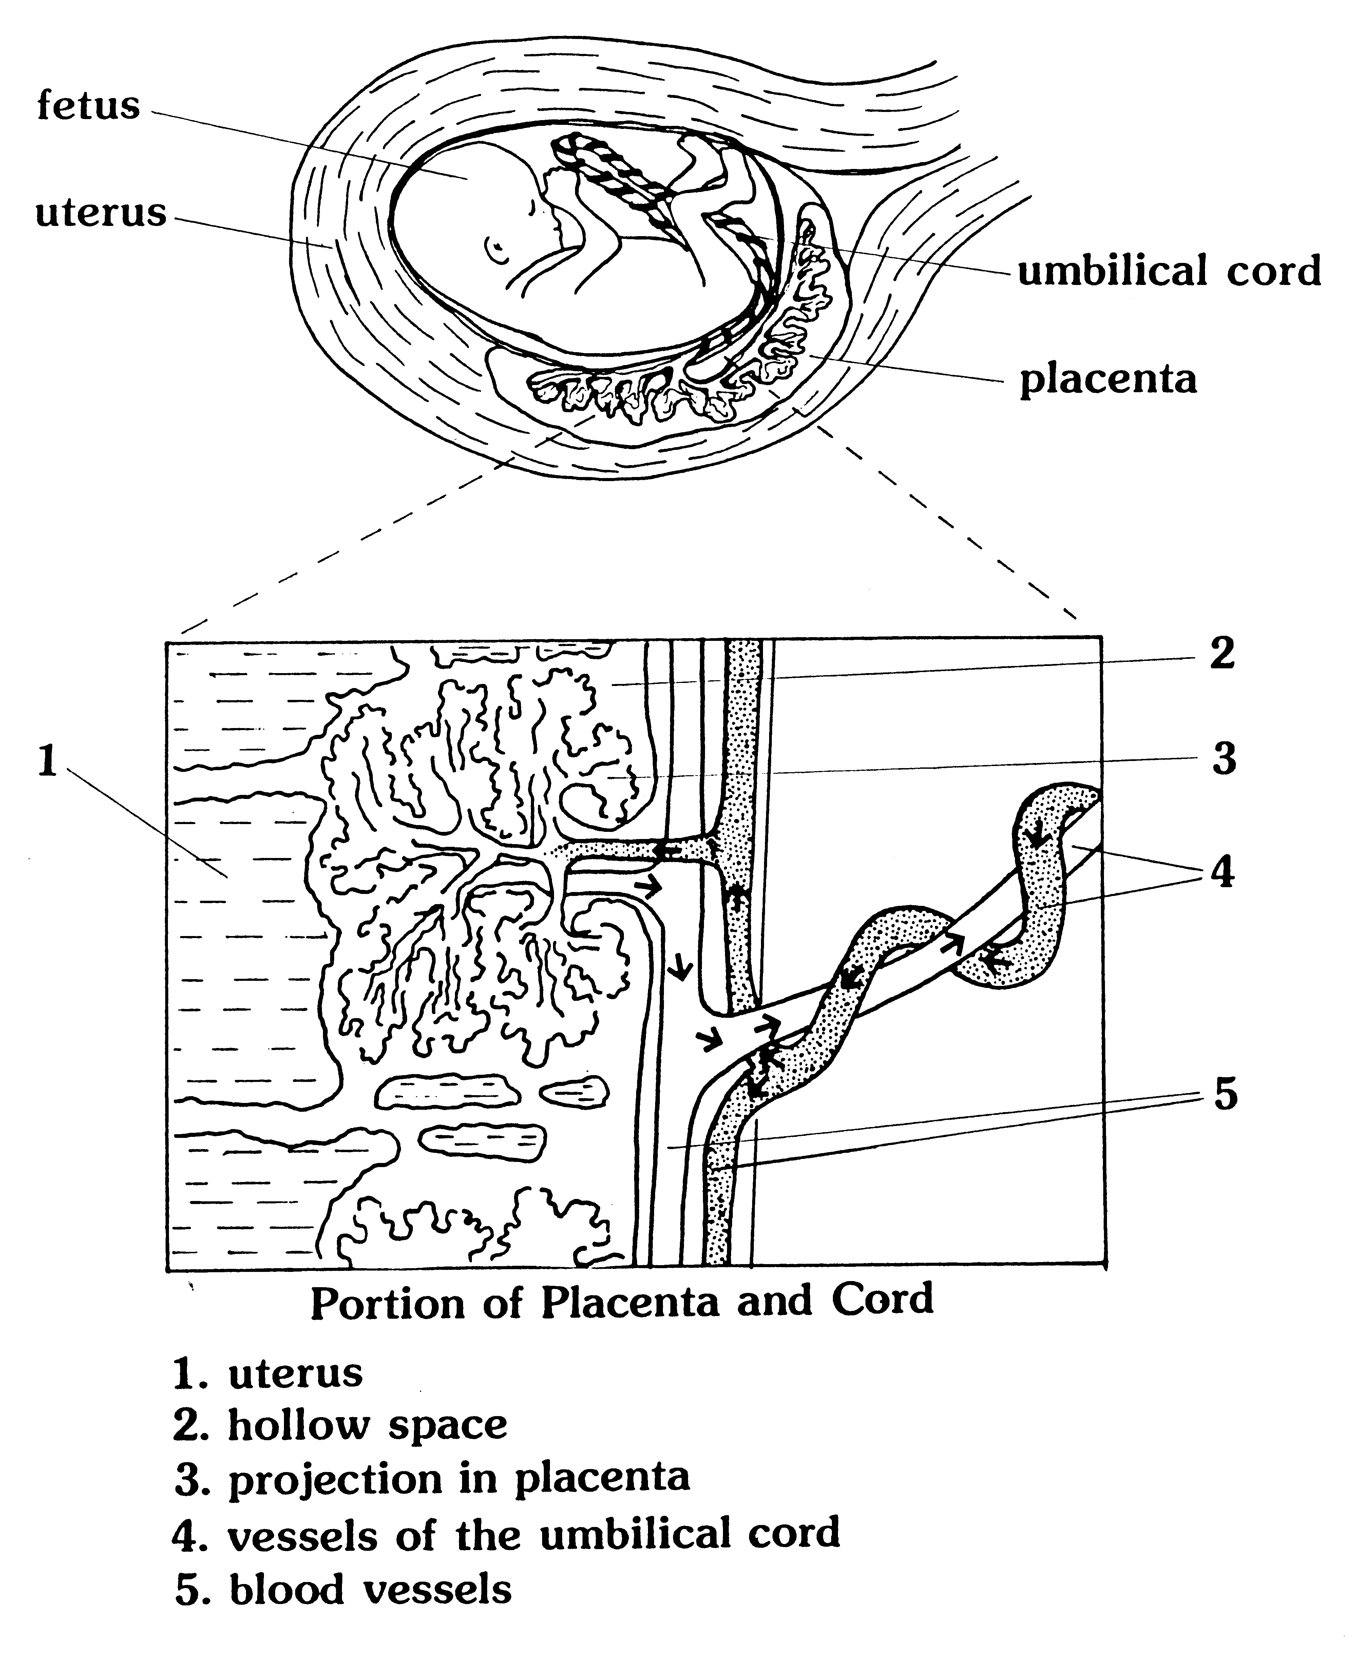

Maternal and Fetal Circulation: Reproduced from Family Life Education, Grade 9. Copyright © 1990 by Manitoba Education and Training.

