 | Reproductive System Diagram:  Male Anatomy―Front View | 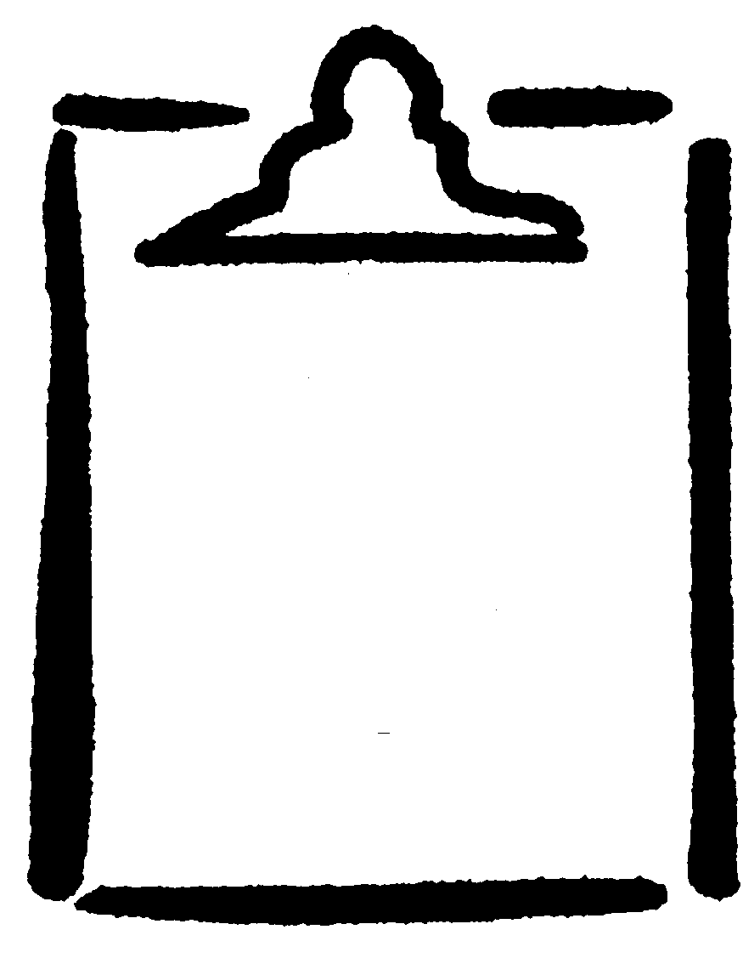  BLM  G-8

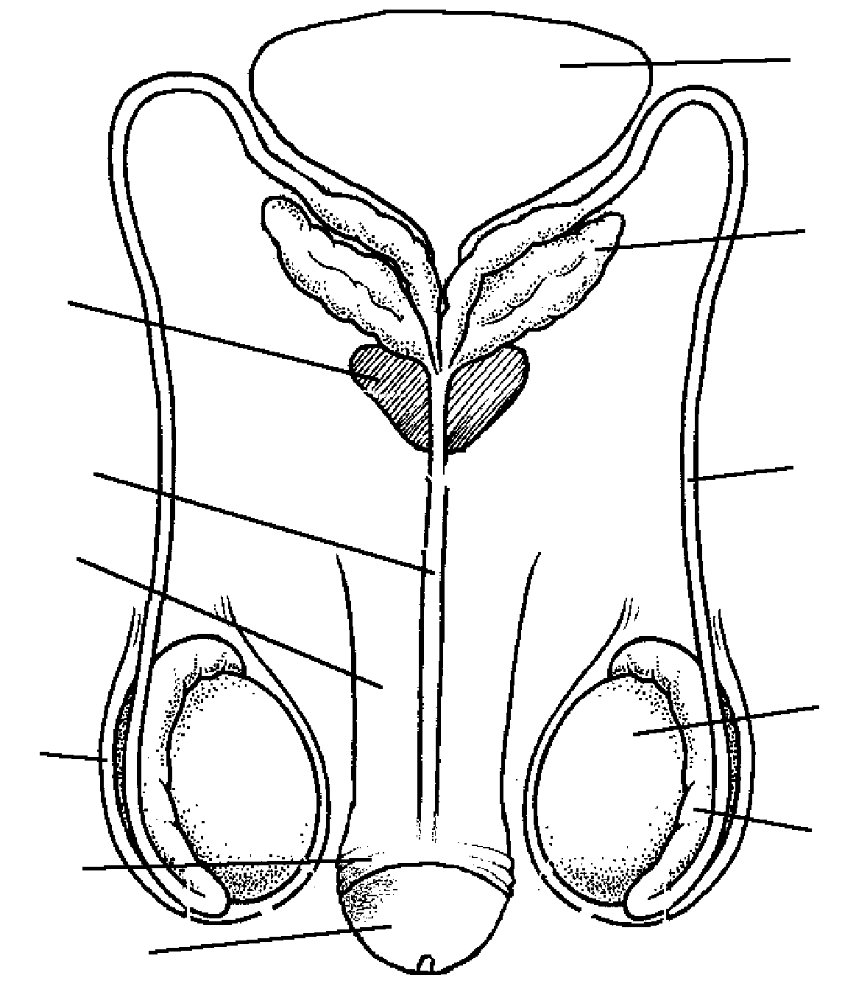
Circumcised

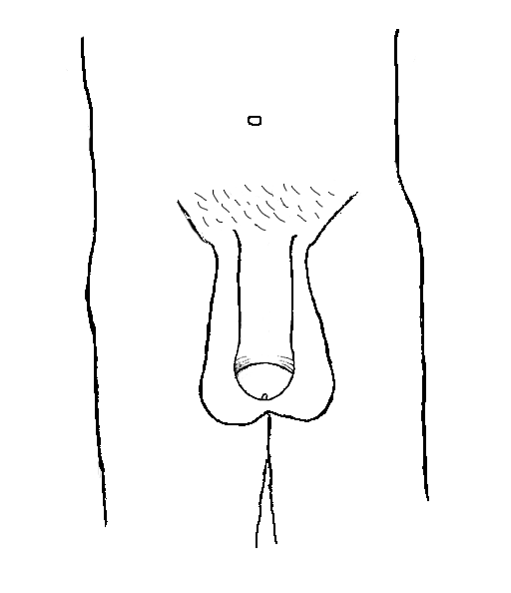

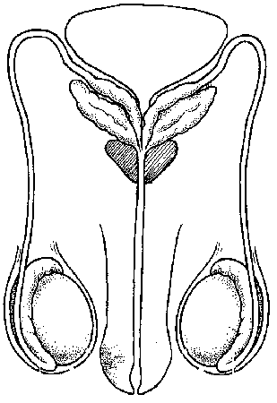
Uncircumcised
Circumcised
Uncircumcised

