 | Reproductive System Diagram:  Male Anatomy―Front View  (Labelled) | 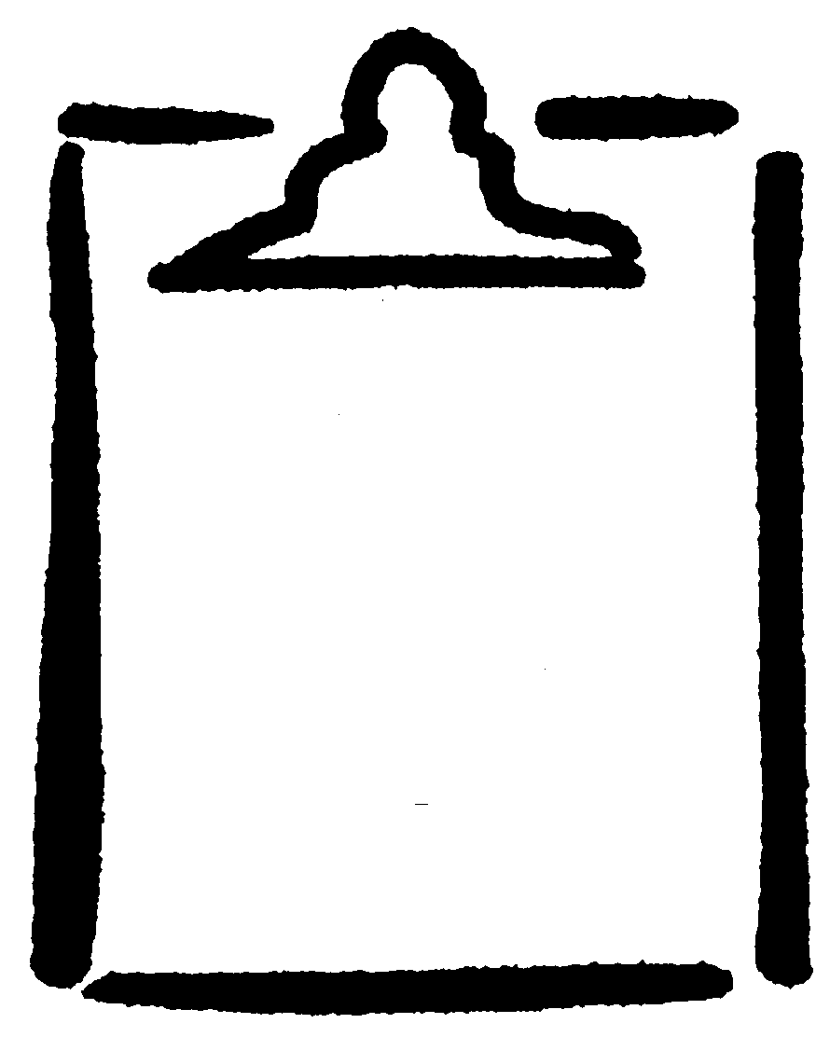  BLM  G-8

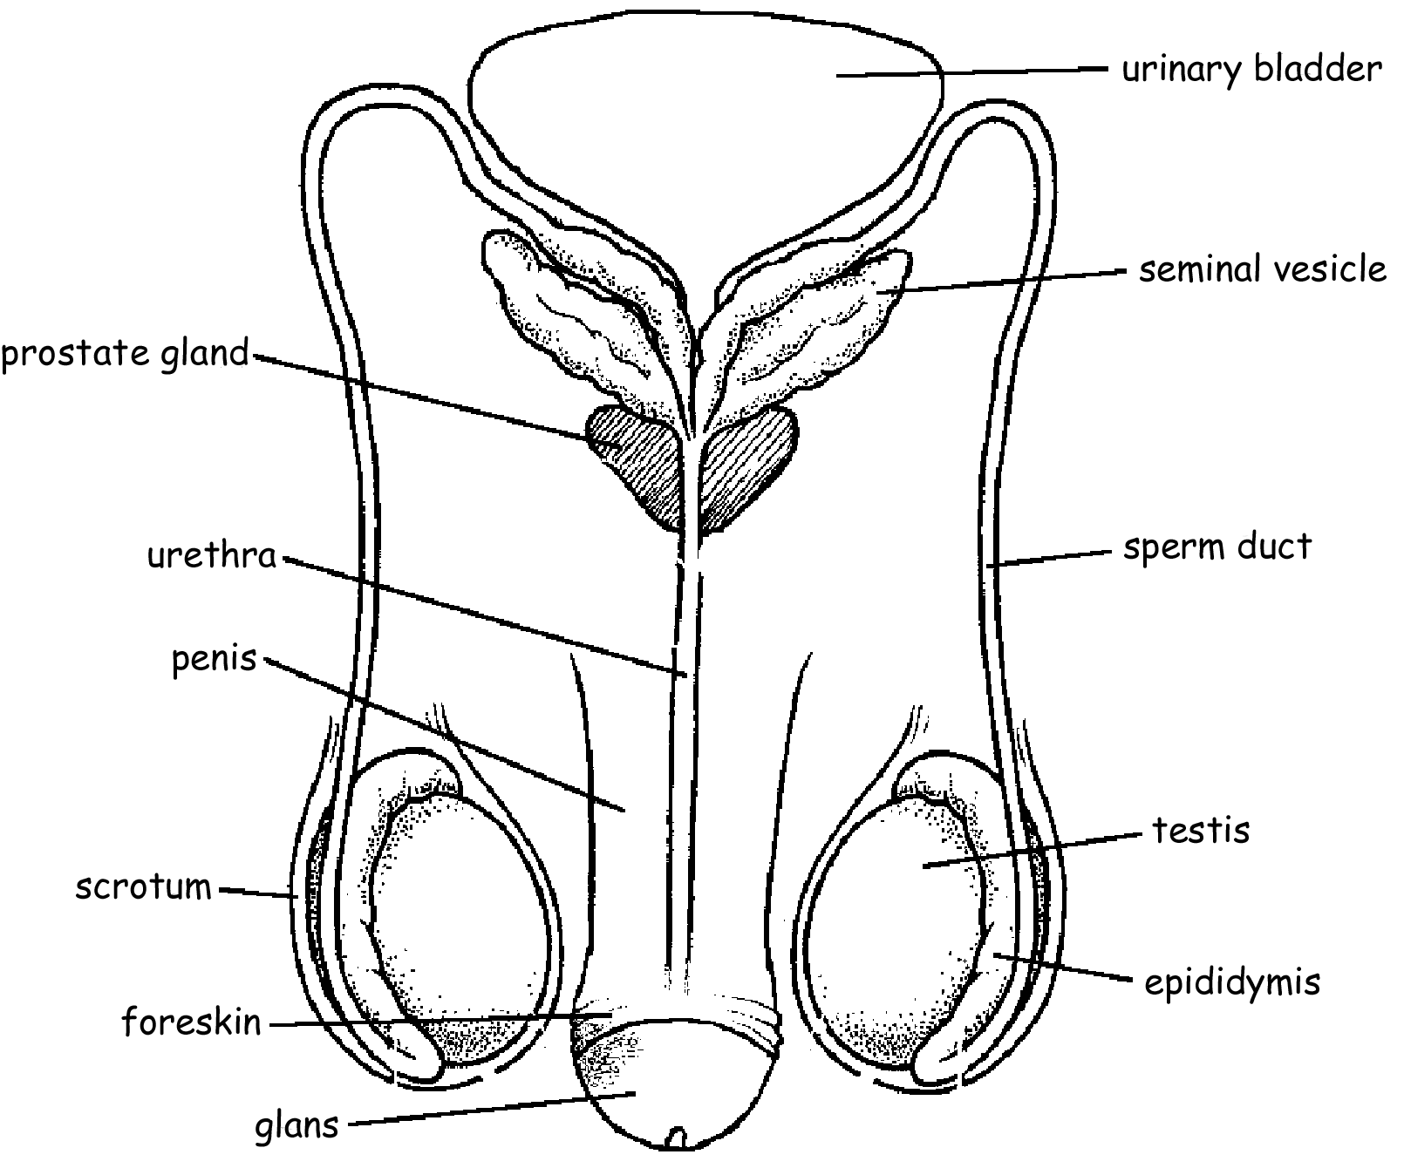

Circumcised

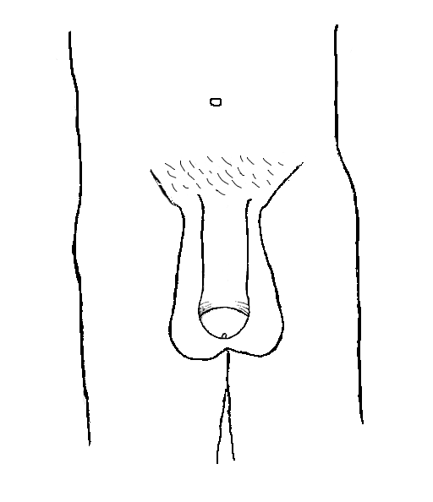

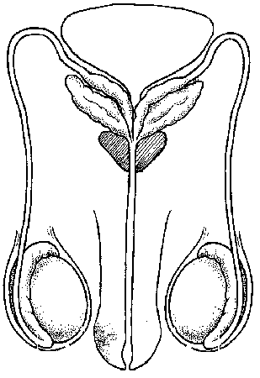

Uncircumcised Circumcised Uncircumcised

