 | Reproductive System Diagram:  Male Anatomy―Side View  (Labelled) | 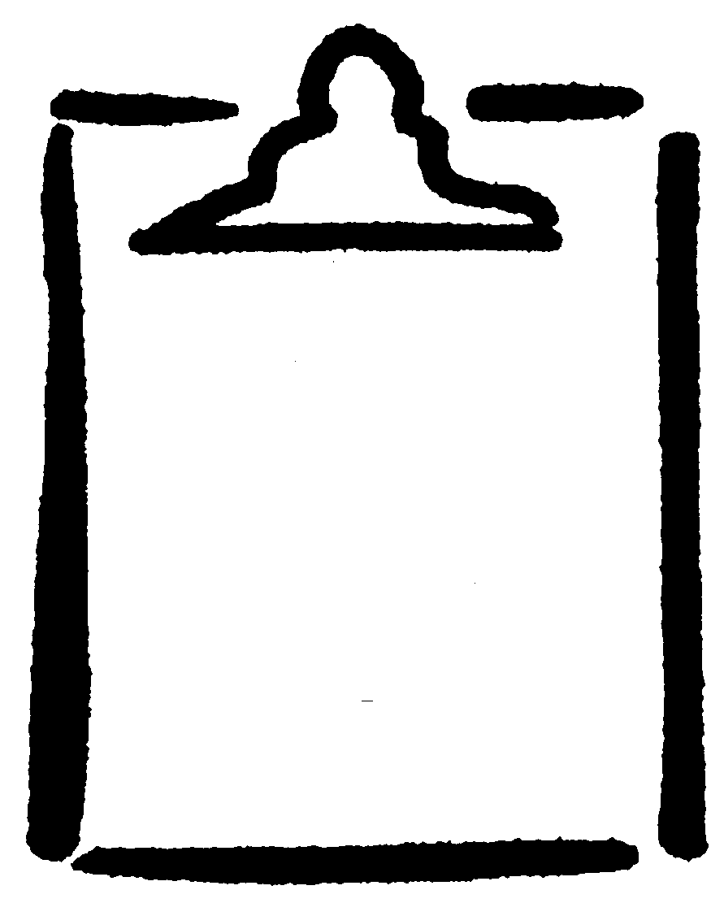  BLM  G-7

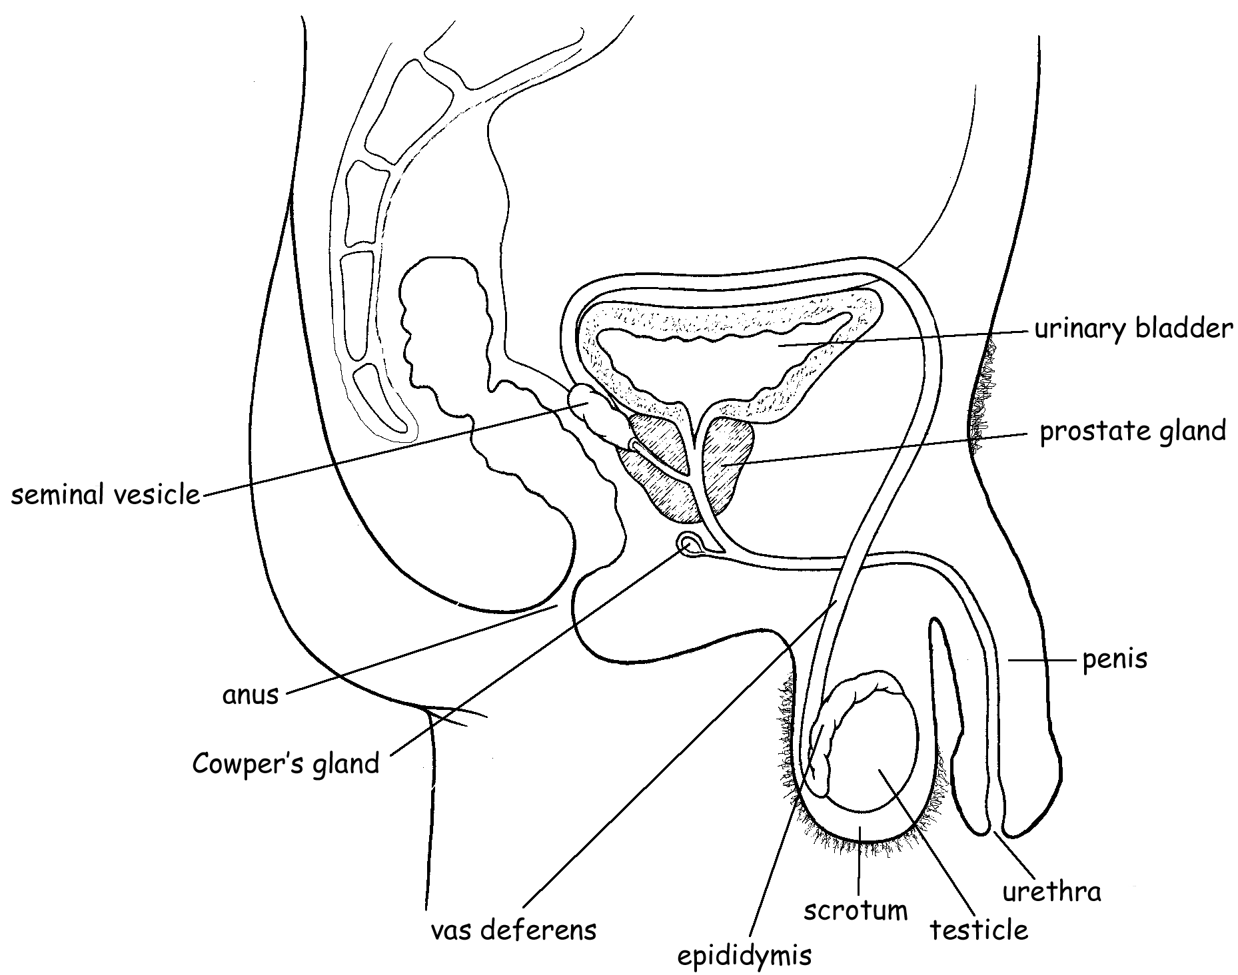

Uncircumcised

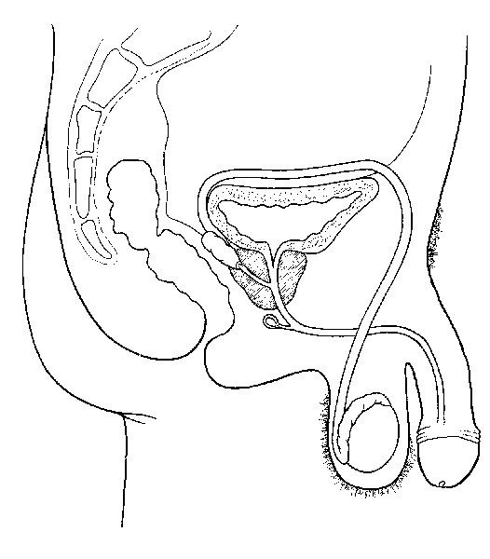
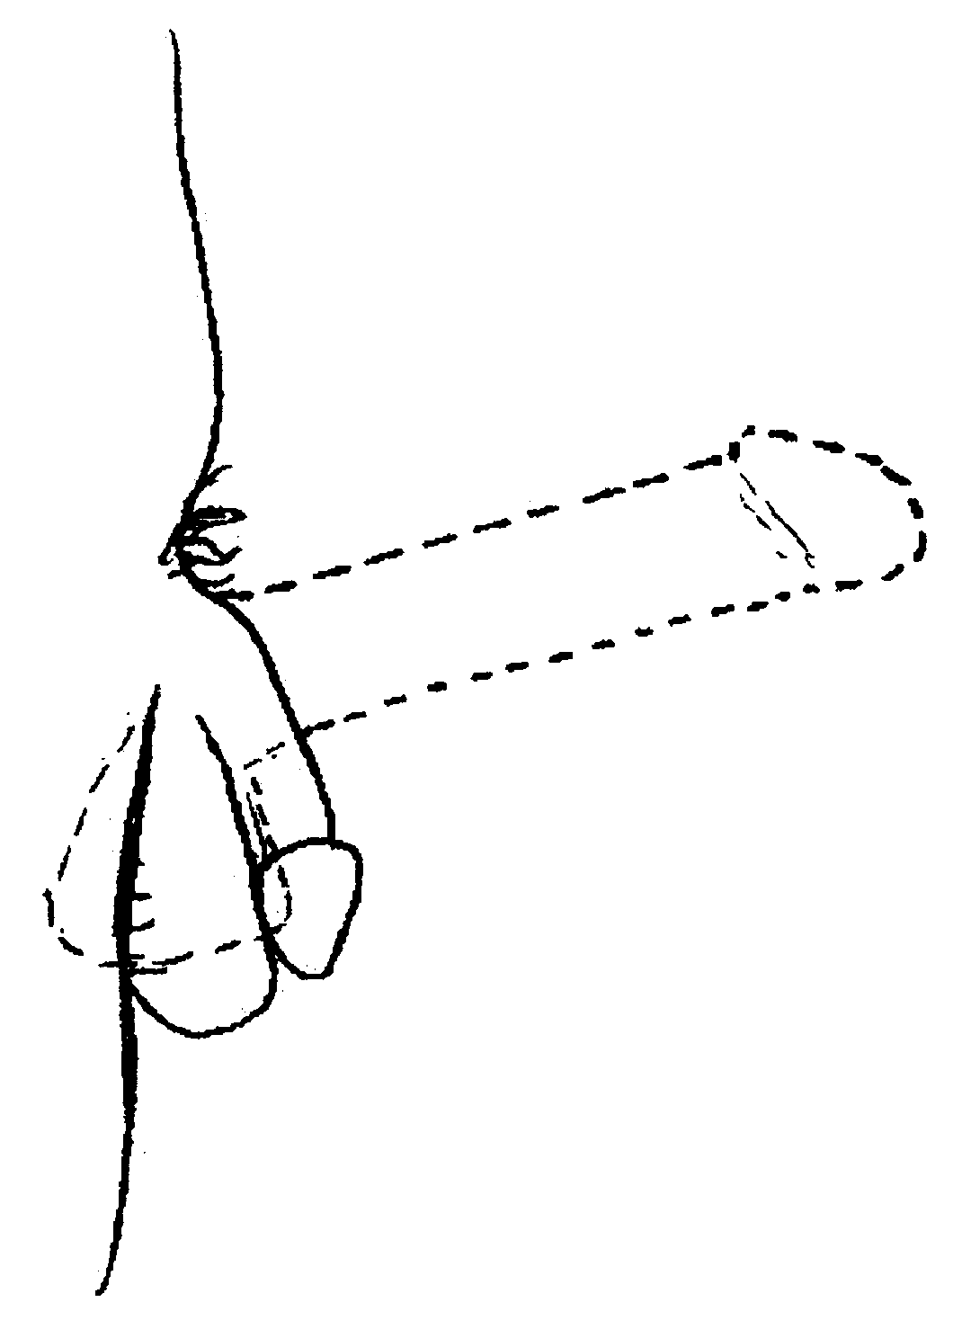

Circumcised Penis during Erection

