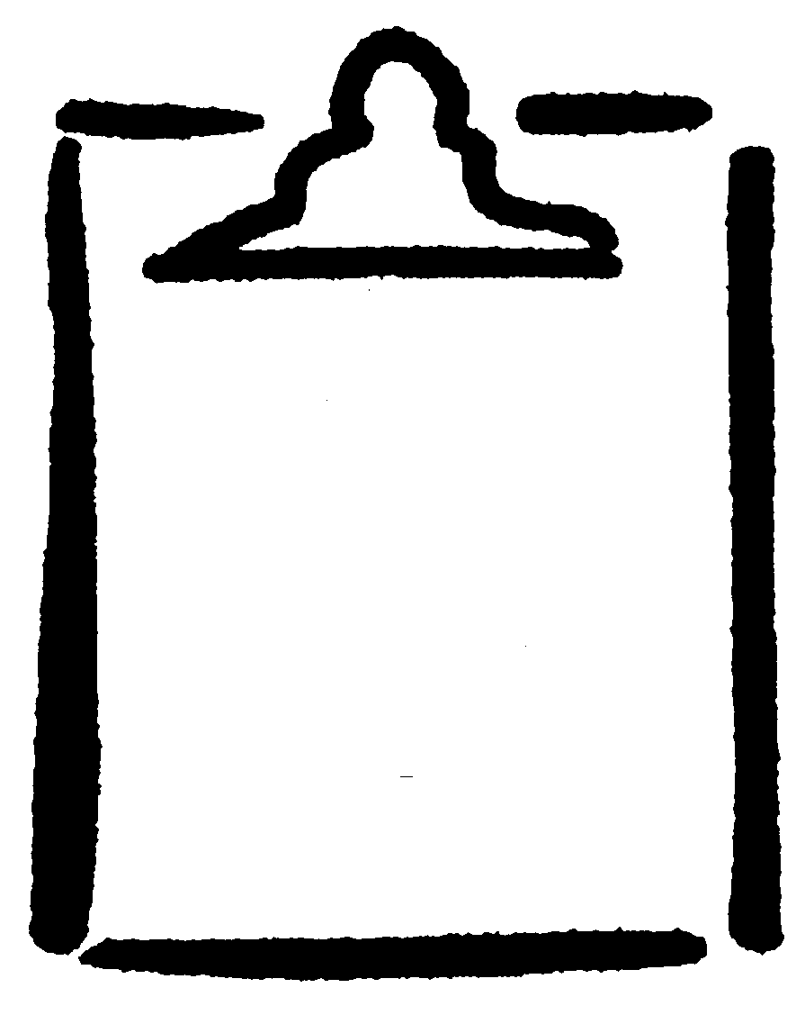 | Reproductive System Diagram:  Female Anatomy—Bottom View,  with Labia Separated  (Labelled) |  | BLM  G-5
