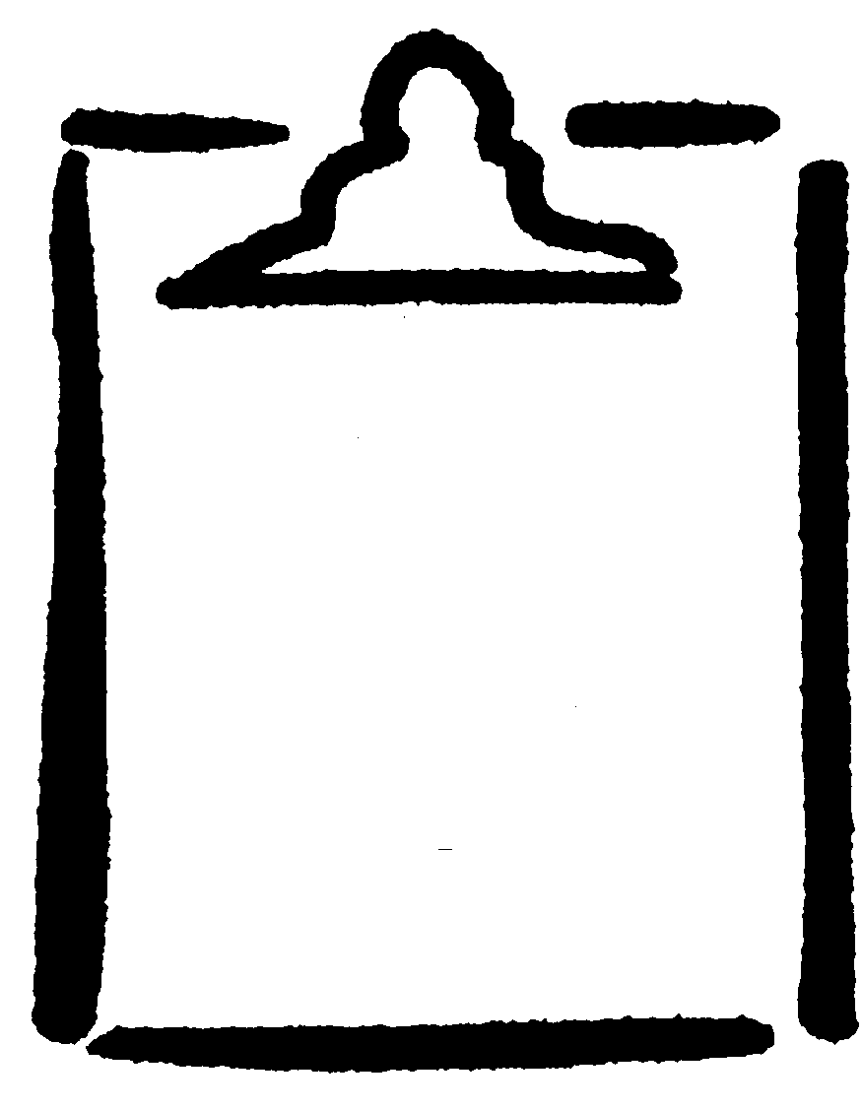
HIV/AIDS Quiz:
BLM
S2-5.1

Answer Key
K.5.S2.E.4a

Name

1. What should you use to minimize mouth-to-mouth contact when performing artificial respiration in order to prevent disease transmission?
Clean mouth barrier.

2. What should you wear when you might be in touch with someone’s blood, body fluids, open wounds, or sores?
Latex gloves, face mask, and face shield.

3. What are the three unsafe practices that could increase your chances of contracting HIV/AIDS?
Unprotected sex, sharing of needles, and contact with blood.

4. HIV is present mainly in semen, blood, vaginal secretions, and breast milk.
True.

5. What does HIV stand for?
Human immunodeficiency virus.

6. What kind of condom protects against HIV?
Latex condom.

7. What does the word “monogamous” mean?
Having sex with only one partner for the duration of a relationship.

8. HIV causes a loss of the immune system to function and the subsequent development of opportunistic infections.

9. There is a cure for HIV.
False (as of 2004).

10. In Canada, when giving blood, all donations are screened for HIV.
True.

11. What does AIDS stand for?
Acquired immune deficiency syndrome.

