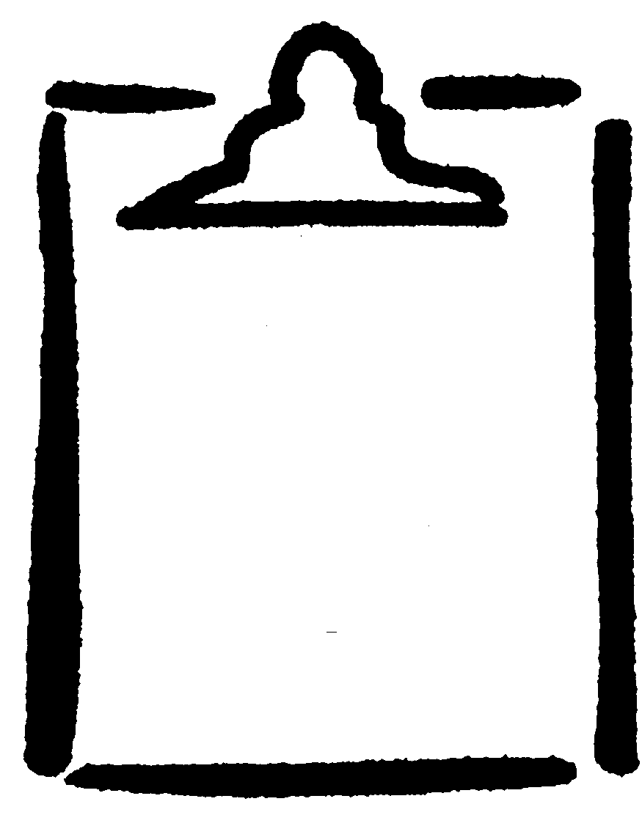
HIV/AIDS Quiz
BLM
S2-5.1
K.5.S2.E.4a

Name

1. What should you use to minimize mouth-to-mouth contact when performing artificial respiration in order to prevent disease transmission?

2. What should you wear when you might be in touch with someone’s blood, body fluids, open wounds, or sores?

3. What are the three unsafe practices that could increase your chances of contracting HIV/AIDS?

4. HIV is present mainly in semen, blood, vaginal secretions, and breast milk.
❑ True  False

5. What does HIV stand for?

6. What kind of condom protects against HIV?

7. What does the word “monogamous” mean?

8. HIV causes a loss of the to function and the subsequent development of opportunistic infections.

9. There is a cure for HIV.
❑ True  False

10. In Canada, when giving blood, all donations are screened for HIV.
❑ True  False

11. What does AIDS stand for?

