K.5.S1.E.4a | HIV/AIDS/STI Knowledge Test | 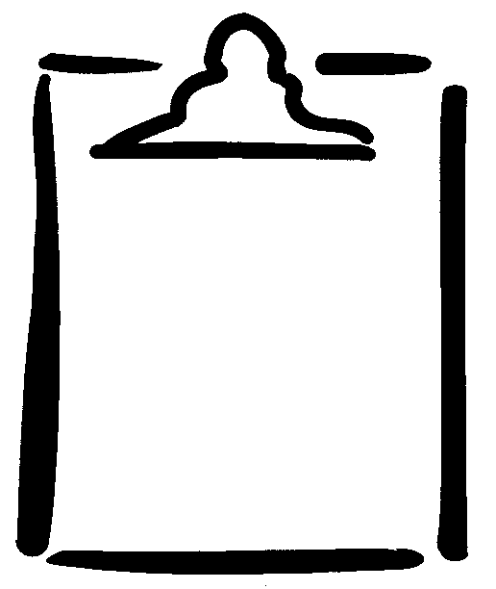  BLM  S1-6.1
Name
Identify each statement as True or False and explain your response.

History of HIV/AIDS
- HIV is caused by AIDS.

- AIDS damages the body’s immune system.

- There is a cure for AIDS.

- Teenagers infected with HIV when they are 14 may not show any AIDS symptoms until their mid-twenties.

Transmission
- Worldwide, the most common way in which HIV is transmitted is through vaginal intercourse.

- Sharing needles for injecting drugs can pass infected blood from one person to another.

- HIV can be spread by casual contact such as hugging, kissing, or holding hands.

- In Canada, it is very unlikely that someone will become infected with HIV by having a blood transfusion.

- A mother with HIV can pass the virus to her unborn child during pregnancy.

- HIV can be transmitted through insect and animal bites.

- A person can pass on a sexually transmitted infection (STI) even though no symptoms are present.
(continued)
K.5.S1.E.4a | HIV/AIDS/STI Knowledge Test  (continued) | BLM  S1-6.1

Prevention
- Latex condom use is the most effective way to avoid HIV.

- The more sexual partners a person has, the greater the chances are that a partner will be infected with HIV.

- Methods for avoiding HIV usually do not help avoid other STIs.

- Sharing needles for ear-piercing or tattooing is safe.

Symptoms
- When someone is infected with HIV, there may be no obvious symptoms.

- Anyone infected with HIV (whether or not symptoms are present) can transmit the infection to others.

- A person can have HIV for years without developing AIDS.

- A person who has had an STI cannot catch it again.

Testing
- Persons having sex with different partners should have regular STI checkups even if they do not have STI symptoms.

Help Sources
- The HIV antibody test is available only to persons who have engaged in high-risk behaviour.

- A person who suspects that he or she has an STI should stop having sex and go to a doctor immediately for an STI checkup.

_______
HIV/AIDS/STI Knowledge Test: Adapted from Health Education (Senior 2) Curriculum Guide. Copyright © 1993 by Manitoba Education and Training.

