
Lesson 2: Privacy
Cluster of Learning Outcomes
Students will…
 K.5.K.E.3a Show the understanding that people have a right to privacy (e.g., in reading corners, time-out zones, washrooms…).
K.4.K.B.1a Identify examples of responsible social behaviours (e.g., contributing by listening, following rules, taking turns, sharing equipment, speaking kindly, being courteous…) for getting along with others in school and schoolyard.

 Indicates targeted learning outcome.
Lesson Focus
As a result of the learning activities within this lesson students will be able to
• identify, draw, and colour a classroom privacy symbol
• itemize ways of respecting a person’s privacy
• state situations where/when they needed privacy
• identify male and female washroom symbols


Resources
Lesson Materials/Supplies
• a classroom privacy symbol (e.g., stuffed animal)
• paper and crayons

Blackline Master
• BLM K-2.1: Washroom Signs


Notes to Teacher
Explain to students that it is sometimes important to have private space, away from others (e.g., take a time out, read a book quietly, go to the washroom).
All humans have the right to spend some time in private where they can think or take care of personal needs. Help students to understand the concept of privacy and the appropriate behaviours they should demonstrate around others who need privacy (e.g., do not interrupt, do not tease or bother others during their time out, knock on the door, close the washroom door).
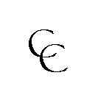

Curricular Connections
ELA:
GLO 5—Celebrate and build community (appreciate diversity, cooperate with others)
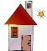
Family Involvement
• Have students take home their pictures of female and male washroom signs and
encourage parents to ask their children to identify the signs in public places.


Suggestions for Instruction
1. Ask students what privacy means to them. Define privacy as quiet personal time.
2. Present three stuffed animals (or other symbols) and ask students to vote for their choice of classroom privacy symbol. Name the symbol. Explain that if a student feels the need for privacy he or she may ask to hold the symbol.
3. Ask students how they can show respect for someone’s privacy (e.g., knock on door, don’t interrupt, respect time-out zone).
4. Have students name situations (at home or school) when they needed privacy (e.g., looking at a book, drawing a special card, listening to music, having a bath or shower, using the toilet).
5. Ask students to draw and colour the classroom privacy symbol and print its name on the drawing.
6. Tour students past the school’s washrooms to observe the signage. In class, have students print the words boys and girls and colour the appropriate symbols.
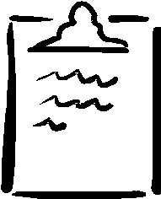
Use BLM K-2.1: Washroom Signs as a handout.


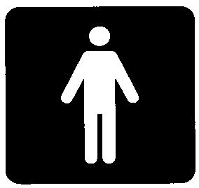
Girls Boys


Suggestions for Assessment
Observation
Teacher: Anecdotal Notes
Keep a record of when and why a student uses a time-out/privacy symbol during class time.

Notes

