My Grade 7 Journal/Learning Log

Name ________________________________________ Class ____________

Human Sexuality

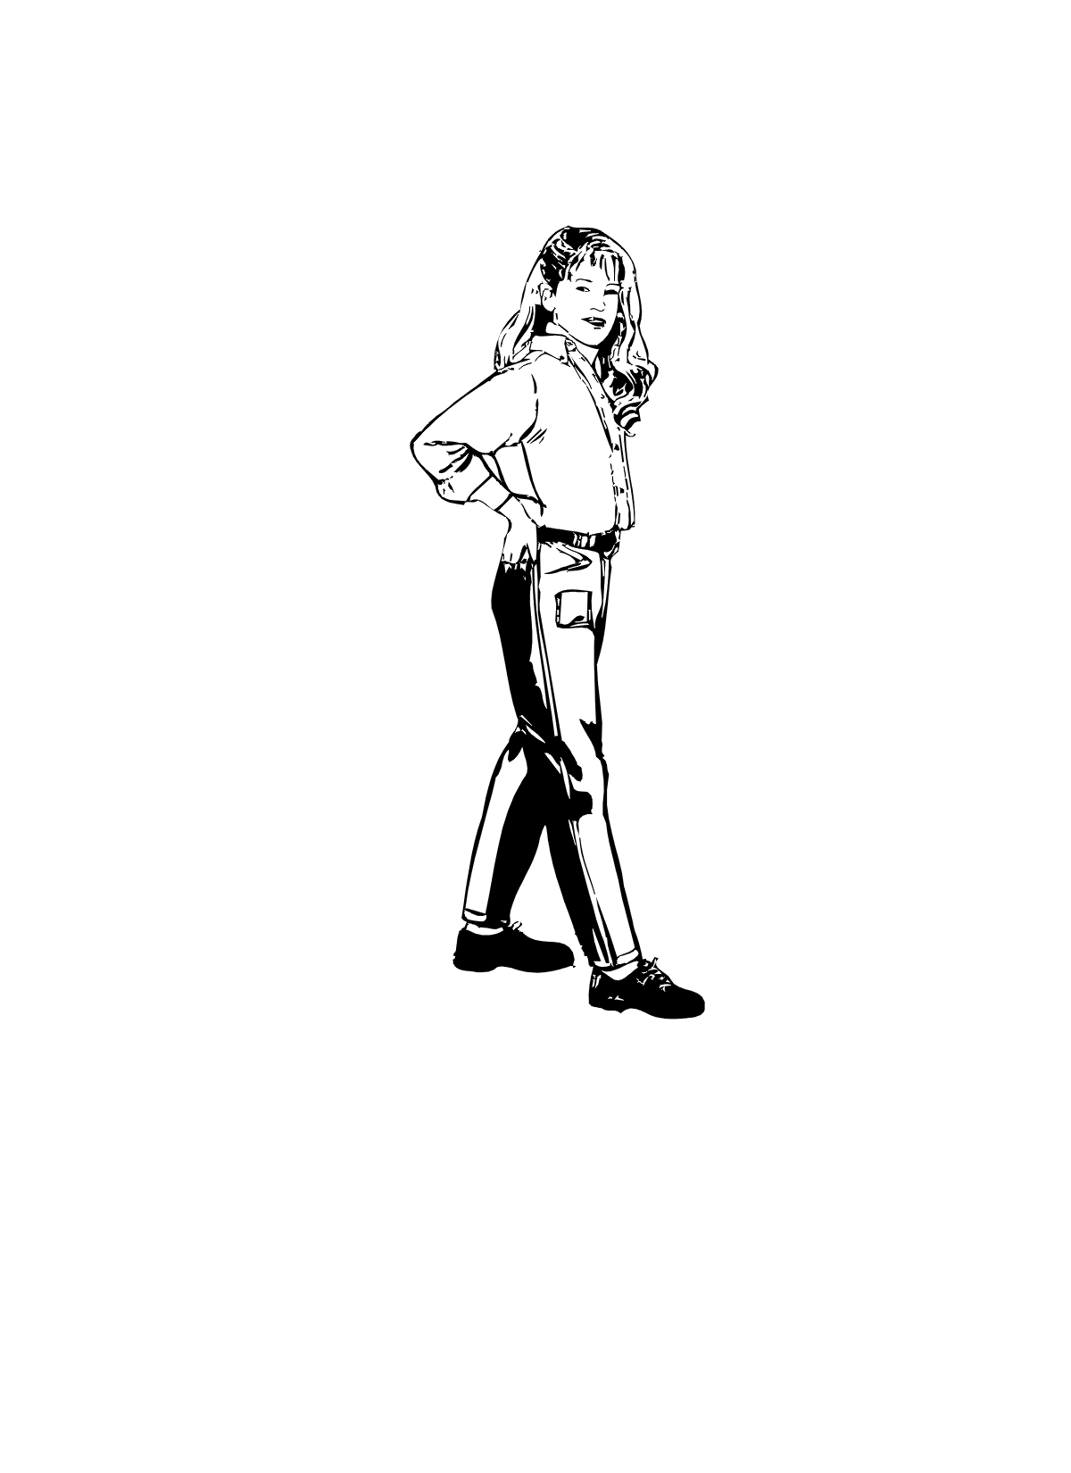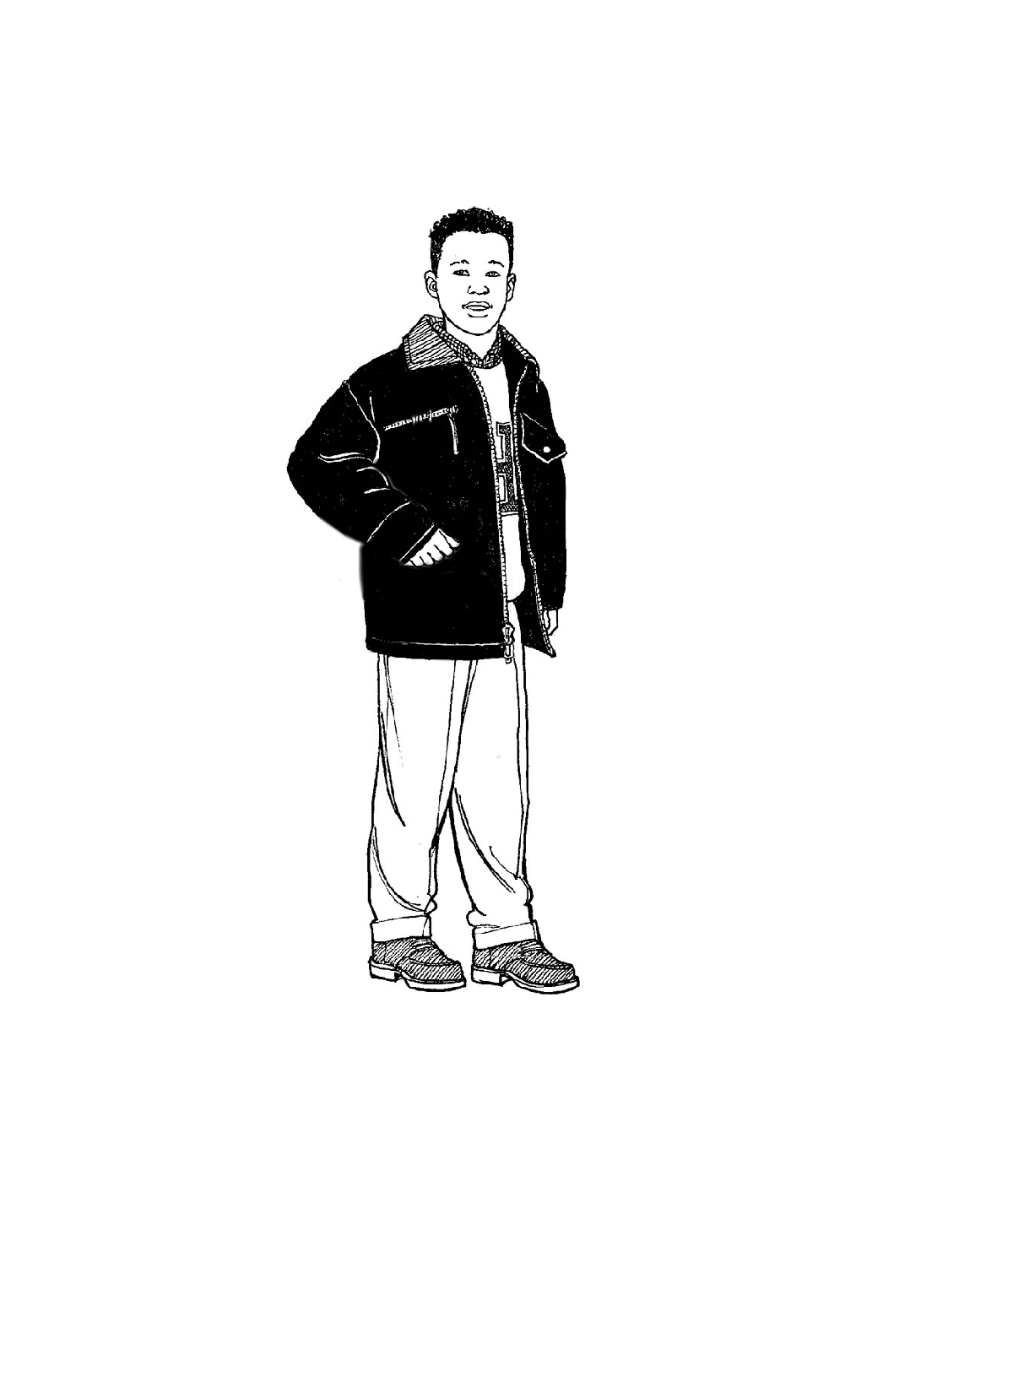

Lesson 1: Reproductive Systems

1. I have completed/labelled the following BLMs:
- BLMs G-1 to G-3: Reproductive System Diagrams: Female Anatomy
- BLMs G-5 to G-7: Reproductive System Diagrams: Male Anatomy
2. Describe one characteristic of the embryo/fetus in each trimester.

3. How many weeks is a human pregnancy?

4. Define fertilization. List three myths about fertilization.

5. Draw a diagram indicating the location of the pituitary gland and explain its function.

Lesson 2: Adjusting to Puberty

1. List three emotional changes that occur during puberty and how each affects personal
well-being.

2. List five ways to cope with the moods and emotions of puberty.

3. Reflect on the past week and complete these sentences:
- One coping mechanism I attempted was…

- The results of this activity were…

Lesson 3: Decision Making and Supports

1. List five advantages of sexual abstinence.

2. Describe a scenario related to responsible sexual decision making.
Work through to a solution using the DECIDE model.
I have completed
- BLM G-9: DECIDE Model
3. Select one source of support (discussed in class) that you would use and explain why.

I have completed
- BLM 7-3.1: Community Supports

Lesson 4: Social Influences

1. Identify effects of social influences on sexuality and gender roles (e.g., related to
fashion, hair styles, make-up, accessories/jewellery, cultural rituals, gender equity, harassment, sports).

Lesson 5: Sexually Transmitted Infections

1. Record some of your thoughts and feelings about issues explored in this lesson. Include
some of the symptoms of STIs and methods of prevention.

