My Grade 5 Journal/Learning Log

Name ________________________________________ Class ____________

Human Sexuality

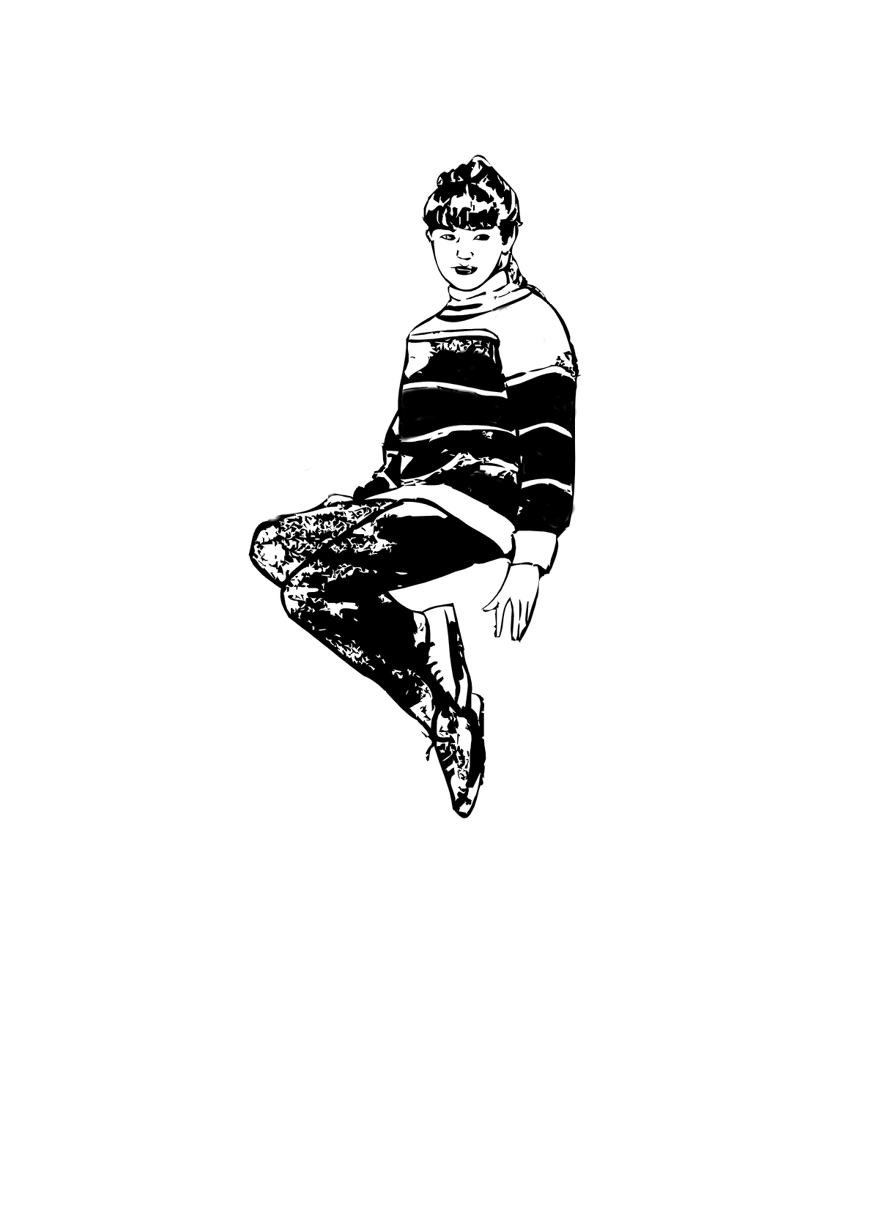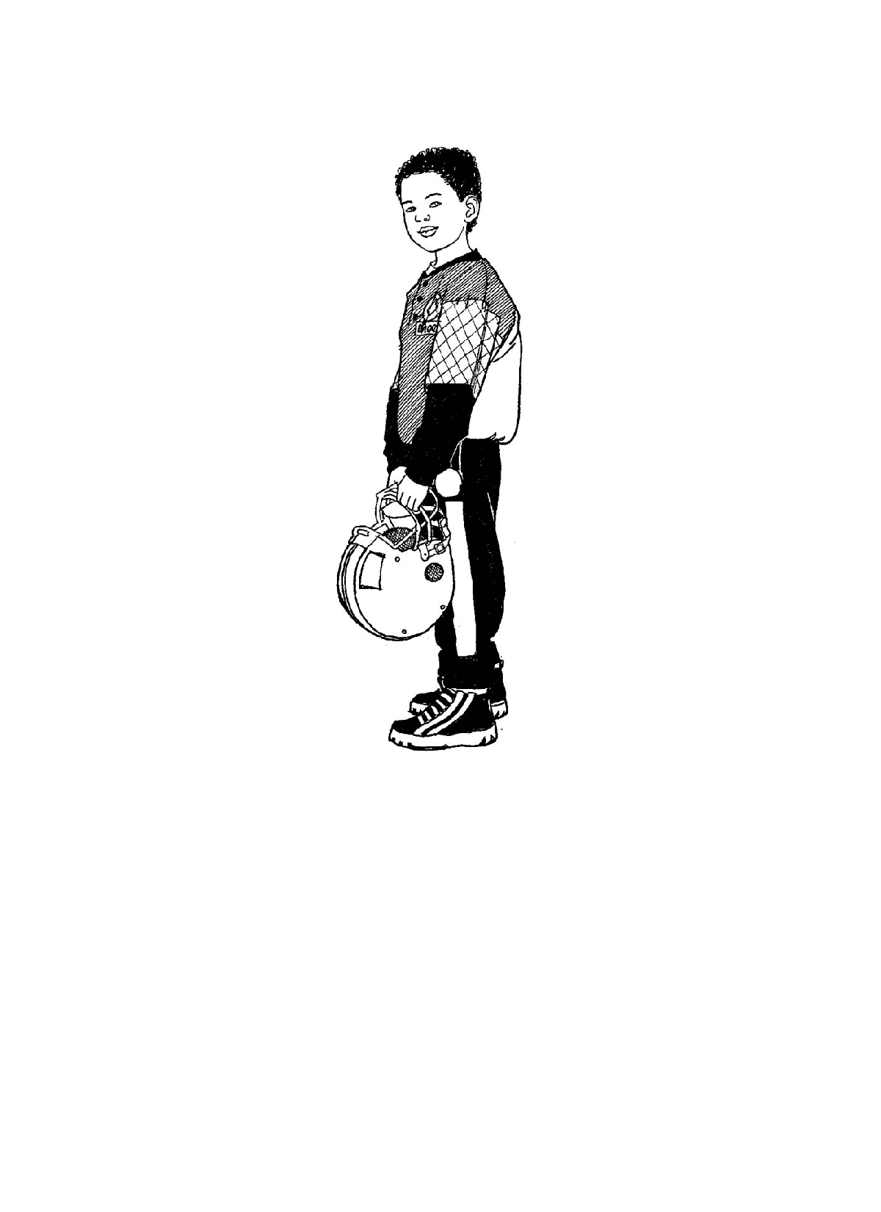

Lesson 1: Reproductive Systems

1. I have completed/labelled the following BLMs:
- BLM 5-1.2: Reproductive Systems: Questionnaire
- BLMs G-1 to G-3: Reproductive System Diagrams: Female Anatomy
- BLMs G-5 to G-7: Reproductive System Diagrams: Male Anatomy
2. Identify features that could be inherited from a parent.
Lesson 2: Puberty

1. What is puberty?

2. Name two physical changes that occur during puberty for
Boys
Girls
Both
3. What are three social-emotional changes that occur during puberty? How might they affect you personally?

4. Describe three personal responsibilities that are related to the changes experienced during puberty.

5. I have completed
- BLM 5-2.1: Puberty Changes
- BLM 5-2.2: Talking about Changes Interview

Lesson 3: Sexuality and Gender Roles

1. Identify what you believe are the top three influences on sexuality and gender roles. Explain why.

2. Give an example of how a social or cultural influence could affect a person’s sexuality.

3. I have completed
- BLM 5-3.1: Looking Back at Childhood: Toys for Males, Females, or Both
Lesson 4: HIV/AIDS

1. Name three ways HIV can be transmitted.

2. What does HIV do to the immune system?

3. Can you get HIV from a public toilet? Why or why not?

Lesson 5: Decision Making

1. Describe a social problem that someone (no names) in your grade might be experiencing.

2. Work through solving the problem using the DECIDE model.
I have completed
- BLM G-9: DECIDE Model

