
Lesson 3: Emotions and Support (Part 2)
Cluster of Learning Outcomes
Students will…
 K.5.2.E.3a Identify ways family or caregivers provide support and nurturing for personal growth and development (e.g., provide food and warmth, express encouragement, listen attentively, provide advice, hugs…).
K.4.2.A.2b List ways to show personal responsibility at home and school (e.g., keep room tidy, put away belongings, follow directions, practise daily health habits, complete homework, respect others, play safely, learn to set boundaries, ask for help, offer to help…).

 Indicates targeted learning outcome.
Lesson Focus
As a result of the learning activities within this lesson students will be able to
• identify specific examples of family/caregiver support
• demonstrate supportive interactions in role-play


Resources
Lesson Materials/Supplies
• props for role-play
• large piece of paper for Y-Chart


Notes to Teacher
Be sensitive to family configurations, gender classification issues, birth and arrival stories of children, illnesses or death of family members, and family living conditions.

Also be sensitive in detecting any student embarrassment, discomfort, or reticence with respect to ways of expressing emotions and affection. For cases of abuse (physical, psychological, sexual) and neglect, follow the school/division policies. Teachers are required by law to report all cases of abuse.

Curricular Connections
ELA:
GLO 1—Explore thoughts, ideas, feelings, and experiences (express ideas)
GLO 4—Enhance the clarity and artistry of communication (generate ideas, organize ideas, effective oral communication, attentive listening and viewing)
GLO 5—Celebrate and build community (celebrate special occasions, cooperate with others)
PE/HE:
GLO 4—Personal and Social Management
SC:
Cluster 1—Growth and Changes in Animals (animals caring for young)

Family Involvement
• Recommend a story about family support and caring for parents to read to their children.
Example of Story:
Oram, Hiawyn. All-Better Bears. Illus. Frédéric Joos. London, UK: Andersen Press, 1999.

Suggestions for Instruction
1. Ask students to discuss how their families or caregivers support and nurture their development (e.g., provide food, shelter, clothes, protection, advice, love, encouragement). Record students’ observations in a Y-Chart that relates how this support and caring “looks,” “sounds,” and “feels.” Use a large piece of paper for the Y-Chart.
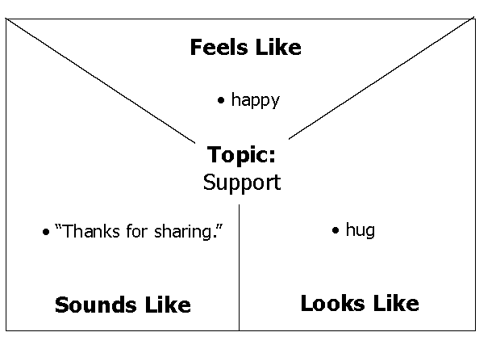

2. Arrange students in groups. Have the groups
• choose a room in a home and use props to set up the selected room
• decide on a family membership/grouping
• create case scenarios or skits showing ways in which family members would talk to each other or treat each other in a supportive and caring environment
• role-play the skits for the class
Ideas for Skits:
• parent helping a child with homework
• child helping to dry dishes
• parent preparing a meal
• brother helping young sister tie shoes
• parent comforting an injured child

Suggestions for Assessment
Observation
Teacher Assessment: Anecdotal Notes

For the Y-Chart activity, record students’ observations during their informal interaction, noting how they describe personal observations, experiences, and feelings. Date and record the context of the observations.
Notes

