
Lesson 1: Growing (Part 2)
Cluster of Learning Outcomes
Students will…
 K.5.2.E.1a Identify basic changes in growth and development from birth to childhood (e.g., changes to teeth, brain, height, body weight, clothes size…).

 Indicates targeted learning outcome.
Lesson Focus
As a result of the learning activities within this lesson students will be able to
• identify factors that change as they grow
• identify factors that remain constant as they grow
• state how babies and adults of the same species are different and alike

Resources
Lesson Materials/Supplies
• students’ baby pictures and recent pictures

Blackline Masters
• BLM 2-1.1: Human Adults and Babies
• BLM 2-1.2: All about Me


Notes to Teacher
Tell students that everyone grows and changes in his or her own unique way.


Curricular Connections
MA:
Shape and Space (length, height, metric, comparing terms, time, months)
Patterns and Relations (patterns based on collected data)
Statistics and Probability (estimating and measuring)
SC:
Cluster 1—Growth and Changes in Animals (animal offspring and changes)
2-1-01 Use appropriate vocabulary related to their investigations of growth and changes in animals.
2-1-02 Identify and describe constant and changing characteristics of humans as they grow and develop.
2-1-03 Recognize that not all humans grow and develop at the same rate.
2-1-09 Compare the appearance of young and mature animals of the same type.

Family Involvement
• Every month, have students take home their own All about Me booklets to share with their families and to record accomplishments or new skills they acquire as they mature.


Suggestions for Instruction
1. Introduce the topic of growing up by asking students to brainstorm ways they have changed since they were babies. Record answers on the classroom board.
2. Have students estimate their height and then measure themselves using the appropriate tools and standard units. Do the same thing for various body parts (e.g., head size, length of foot). Repeat the activity in a few months’ time and have students compare the results. Each time, have students show the results on a bar chart. Have them compare and interpret the data (e.g., the body grows, everyone grows at his or her own pace).
3. Identify and discuss the constant and changing characteristics of humans as they grow and develop (e.g., eye colour, height, new teeth). Ask students to record information in a T-Chart.
Stays the Same | Changes

4. Have students compare babies and adults of one species. This may be represented on a Venn diagram. Record answers on the board.
Example:
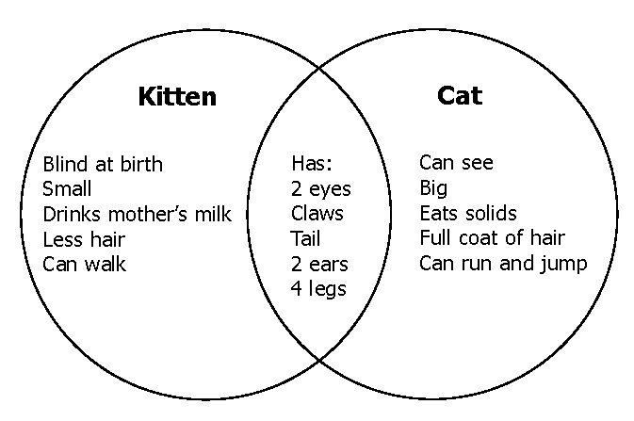

- Have students compare human adults and babies. Ask them to record their answers on a Venn diagram.

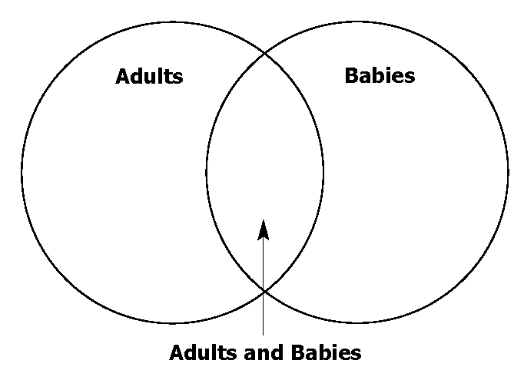

Alternative:
Have students complete the compare and contrast activity using the BLM provided.

Refer to BLM 2-1.1: Human Adults and Babies.

6. Have students draw a picture of a baby and an adult from the same species.
7. Discuss, and have students create, an autobiographic booklet entitled All about Me. Ask students to
• include a baby picture and a recent picture
• record some of the things they can do now that they could not do as babies
8. Discuss the advantages of maturing. Each month, have students record new body changes and abilities. Have them comment on these changes on a BLM provided.
Refer to BLM 2-1.2: All about Me.


Suggestions for Assessment
Journal/Learning Log Entry
Teacher Assessment: Checklist
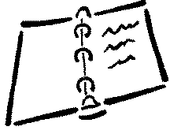
Ask students to make the following entry in their journals/learning logs:

“You are seven years old. Your body has changed in several ways since you were born. Name at least three changes. Give as much detail as possible about each change. Draw the changes.”
Change 1: ______________________________
Change 2: ______________________________
Change 3: ______________________________

Suggested Criteria:
• Look for examples in the drawings related to changes in
❑ teeth
❑ size of head, hands, feet
❑ height
❑ clothing size
❑ shoe size
❑ hair
• Ask students to record one thing that is the same now as when they were born (e.g., 2 eyes, 10 fingers).

