K.5.K.E.1a | How We Cover  Our Private Body Parts |  | 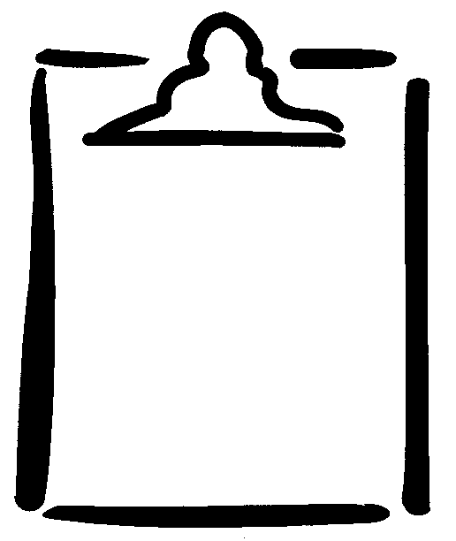  BLM  K-1.2
Name |  | Class | Date

