BLM  G-6 | Reproductive System Diagram:  Male Anatomy―Front View | 

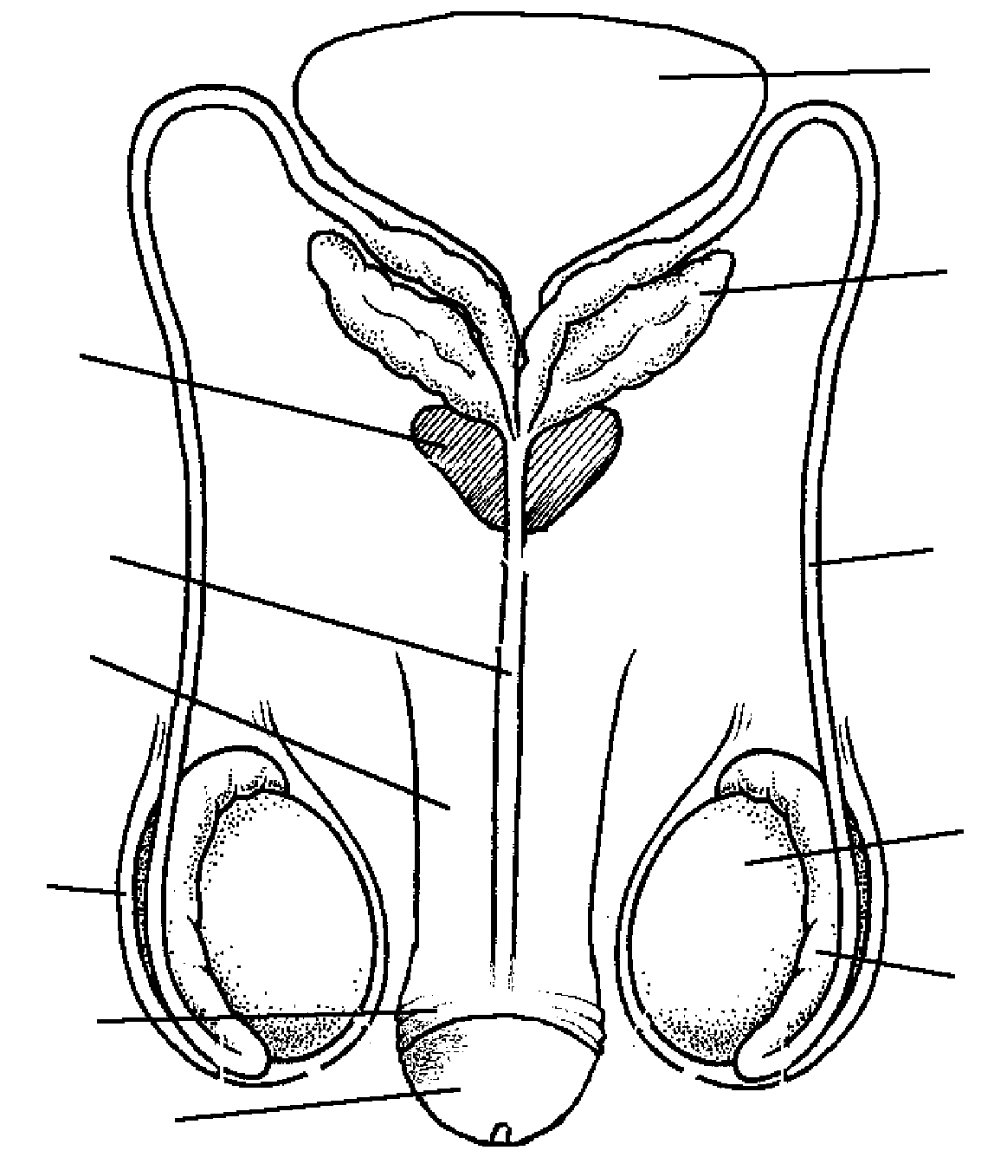
Circumcised

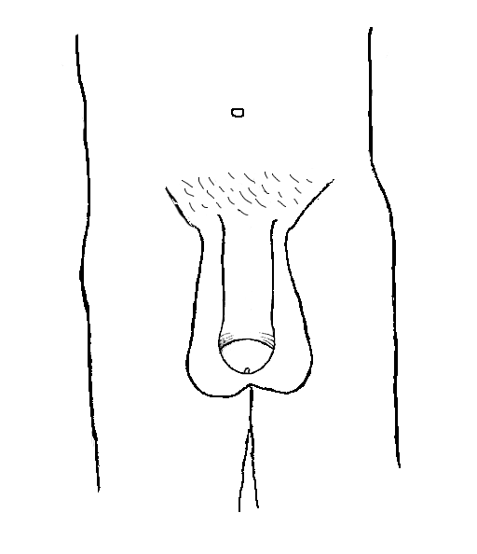

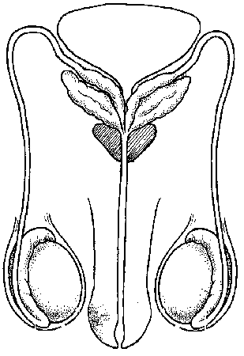
Uncircumcised
Circumcised
Uncircumcised

