BLM  G-6 | Reproductive System Diagram:  Male Anatomy―Front View  (Labelled) | 

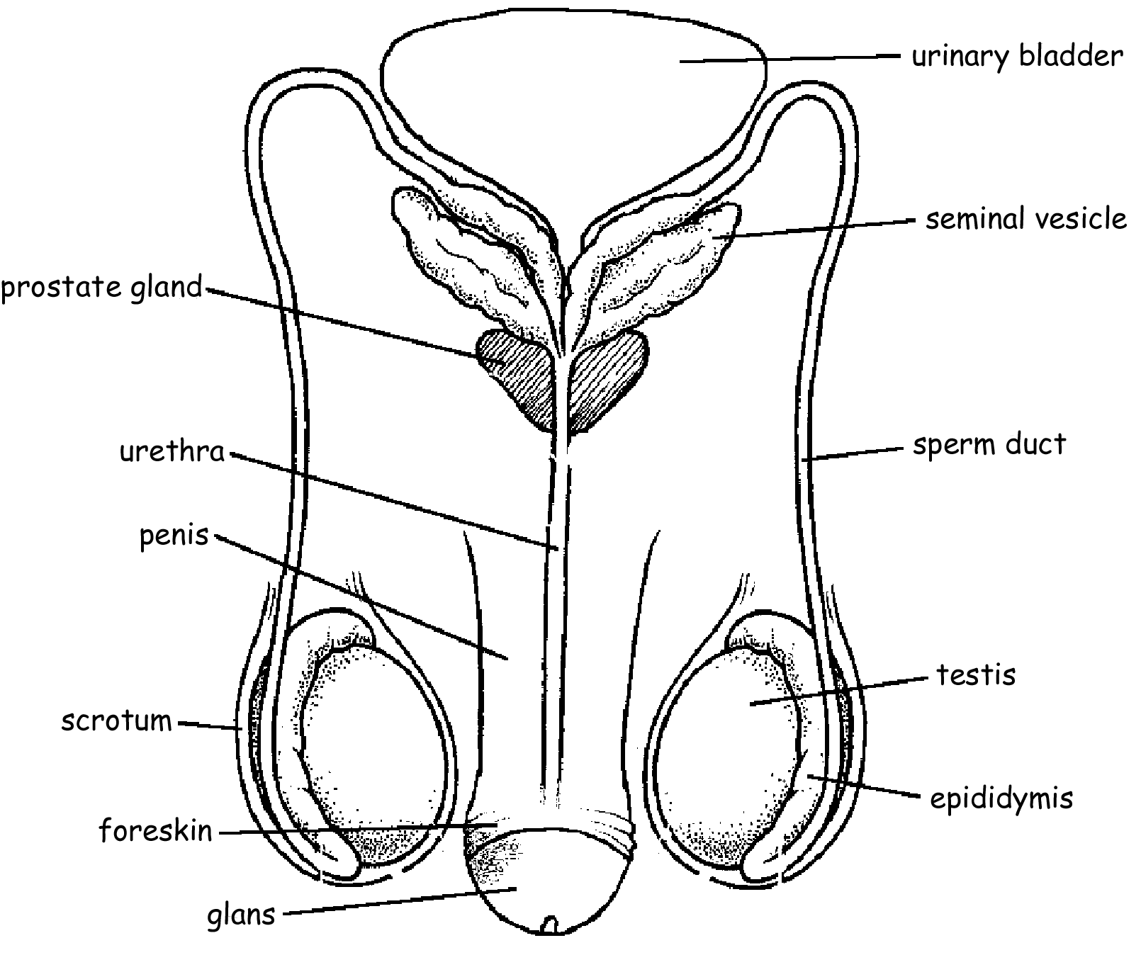

Circumcised

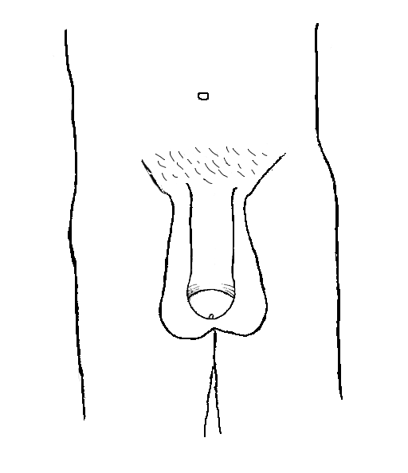

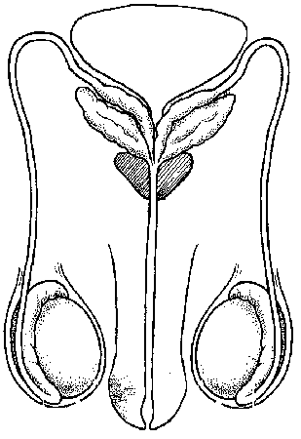

Uncircumcised Circumcised Uncircumcised

