BLM  G-5 | Reproductive System Diagram:  Male Anatomy―Side View  (Labelled) | 

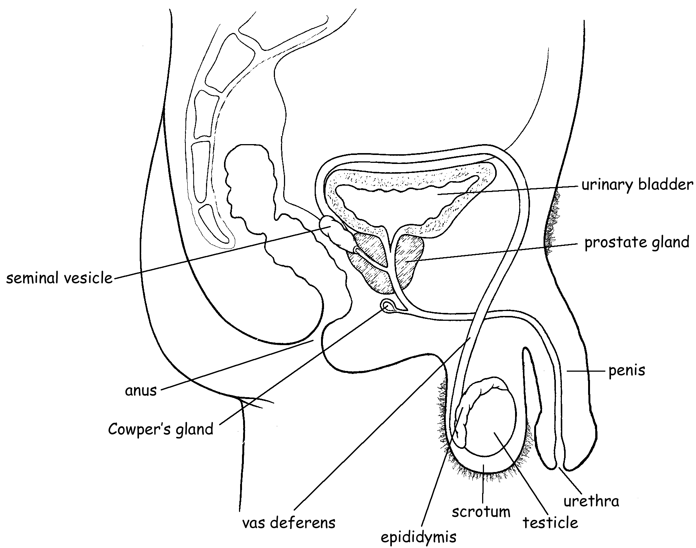

Uncircumcised

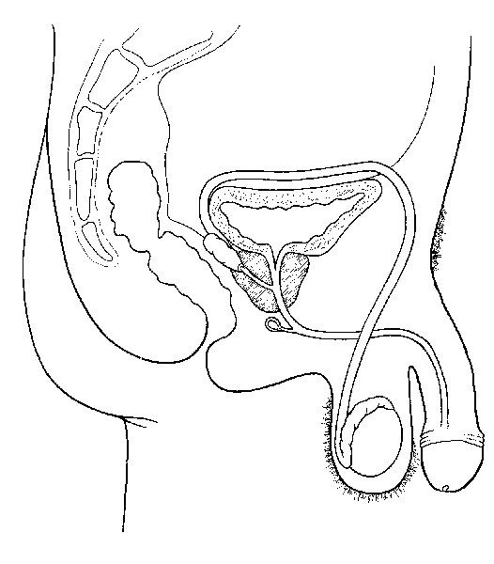
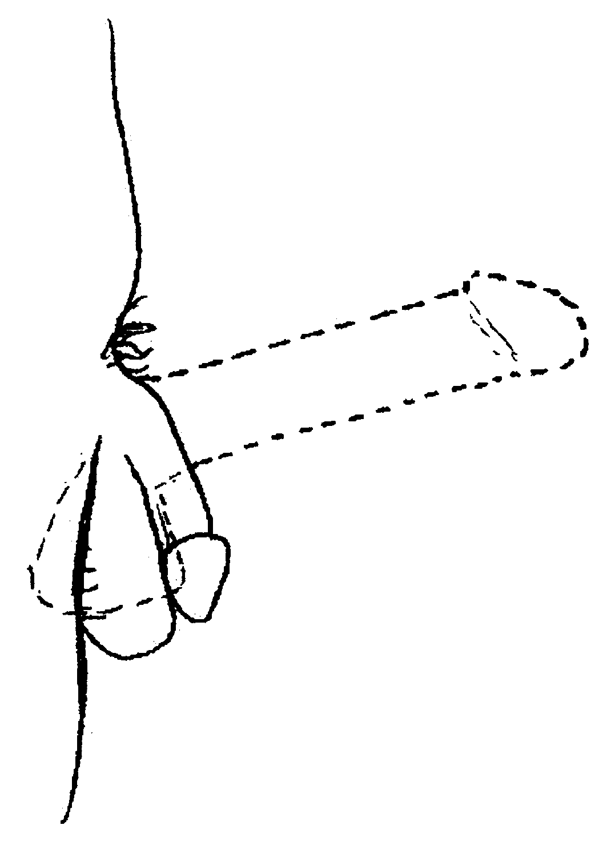

Circumcised Penis during Erection

