K.5.5.E.3a  K.5.5.E.3b | Looking Back at Childhood:  Toys for Males, Females, or Both |  | 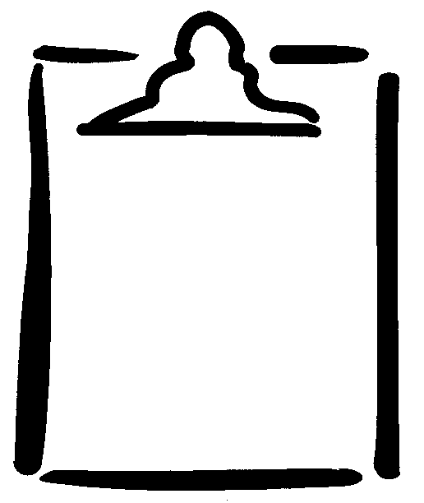  BLM  5-3.1
Name |  | Class | Date
Put a check mark in the boxes below to show who would typically play with each item.
❑ M-Male  F-Female  B-Both
❑ M  F  B |  | ❑ M  F  B |  | ❑ M  F  B
❑ M  F  B |  | ❑ M  F  B |  | ❑ M  F  B
 |  | 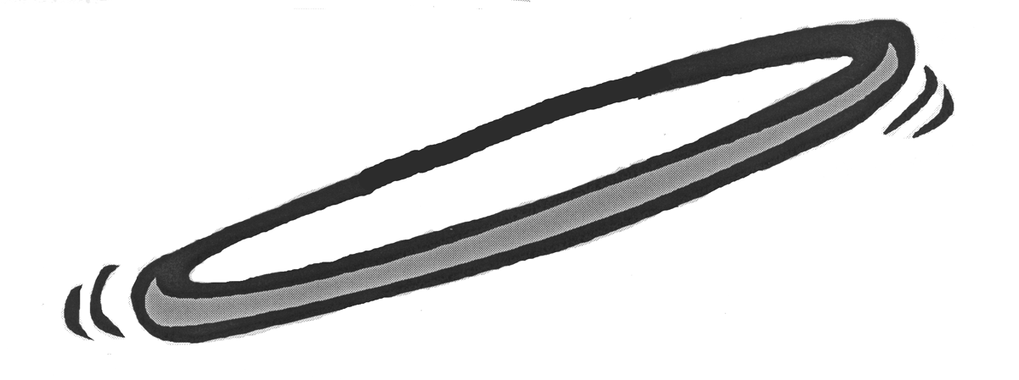
❑ M  F  B |  | ❑ M  F  B |  | ❑ M  F  B
❑ M  F  B |  | ❑ M  F  B |  | ❑ M  F  B

