K.5.5.E.1b  K.5.5.E.2 | Puberty Changes |  |  |  |  |  |  | 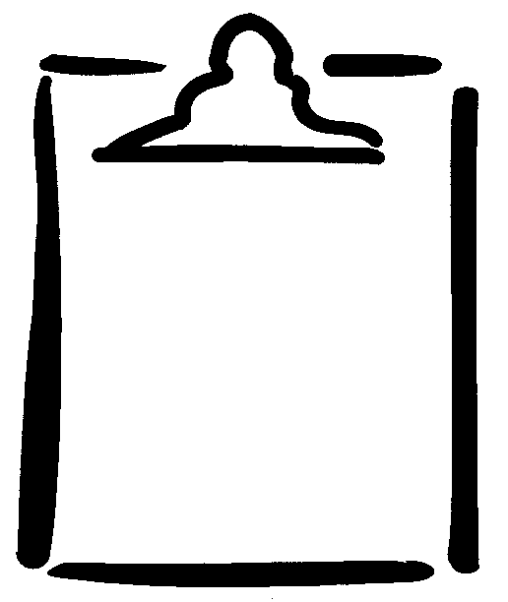  BLM  5-2.1
Name |  | Class |  |  |  | Date
Changes |  |  | Identify changes that occur for…
 |  |  | Males Only (M) |  | Females Only (F) |  | Both Males and Females (B)
1. Breasts begin to grow.
2. Breasts swell or feel uncomfortable.
3. Height increases.
4. Weight increases.
5. Feelings of clumsiness occur.
6. Voice deepens.
7. Mood changes.
8. Need to be independent increases.
9. Skin gets oilier.
10. Perspiration increases.
11. Scrotum gets larger.
12. Hair grows in pubic area.
13. Menstruation begins.
14. Hair grows under arms and on legs.
15. First ejaculation of semen occurs.
16. Wet dreams occur.
17. Hair grows on chest.
18. Penis increases in length and width.
19. Vaginal discharge may be noticeable.
20. Acne develops.
21. Shoulders grow wider/broader.
22. Hips grow wider.
23. Feelings of insecurity may develop.
24. Need to conform or fit in with others increases.

K.5.5.E.1b  K.5.5.E.2 | Puberty Changes:  Answer Key |  |  |  |  |  | BLM  5-2.1
Name |  | Class |  | Date
Changes |  |  | Identify changes that occur for…
 |  |  | Males Only (M) |  | Females Only (F) | Both Males and Females (B)
1. Breasts begin to grow. |  |  |  |  | F
2. Breasts swell or feel uncomfortable. |  |  |  |  |  | B
3. Height increases. |  |  |  |  |  | B
4. Weight increases. |  |  |  |  |  | B
5. Feelings of clumsiness occur. |  |  |  |  |  | B
6. Voice deepens. |  |  | M
7. Mood changes. |  |  |  |  |  | B
8. Need to be independent increases. |  |  |  |  |  | B
9. Skin gets oilier. |  |  |  |  |  | B
10. Perspiration increases. |  |  |  |  |  | B
11. Scrotum gets larger. |  |  | M
12. Hair grows in pubic area. |  |  |  |  |  | B
13. Menstruation begins. |  |  |  |  | F
14. Hair grows under arms and on legs. |  |  |  |  |  | B
15. First ejaculation of semen occurs. |  |  | M
16. Wet dreams occur. |  |  | M
17. Hair grows on chest. |  |  | M
18. Penis increases in length and width. |  |  | M
19. Vaginal discharge may be noticeable. |  |  |  |  | F
20. Acne develops. |  |  |  |  |  | B
21. Shoulders grow wider/broader. |  |  |  |  |  | B
22. Hips grow wider. |  |  |  |  | F
23. Feelings of insecurity may develop. |  |  |  |  |  | B
24. Need to conform or fit in with others increases. |  |  |  |  |  | B

