 | Case Scenarios |  | 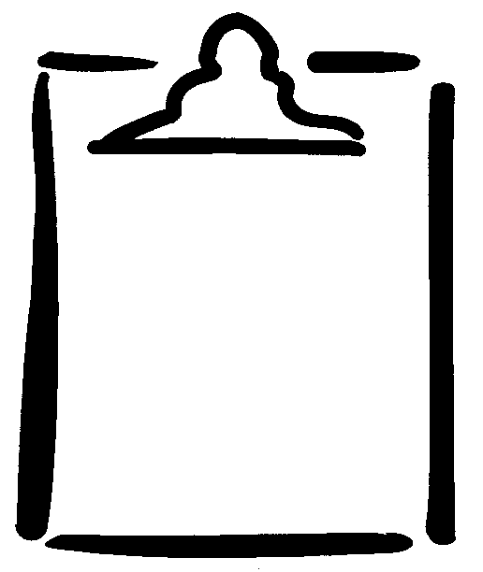  BLM  2-4.1

Scenario 1
Shama is reading quietly on the bed in her room. She does not want to be disturbed. Her sister comes into her room and looks around in her closet. They call each other names.

Scenario 2
Amir is in his bedroom dressing when his sister comes in to remind him to return her CD. He tells his sister to leave immediately. She refuses and uses foul language.

Scenario 3
Marie is ready to take a bath. Her brother René accidentally comes into the bathroom. Marie gets angry and René answers with a rude gesture before leaving.

Scenario 4
Your friend’s dad is driving the two of you to a mall. The driver in the next lane cuts in front of the car. Your friend’s dad honks the horn. The other driver makes a rude gesture.

Scenario 5
You are pushing the grocery cart in a crowded store to help your mom. You accidentally bump the cart into the person in front of you. She turns and yells at you, calling you a “stupid kid.”

