 | Human Adults and Babies |  |  | 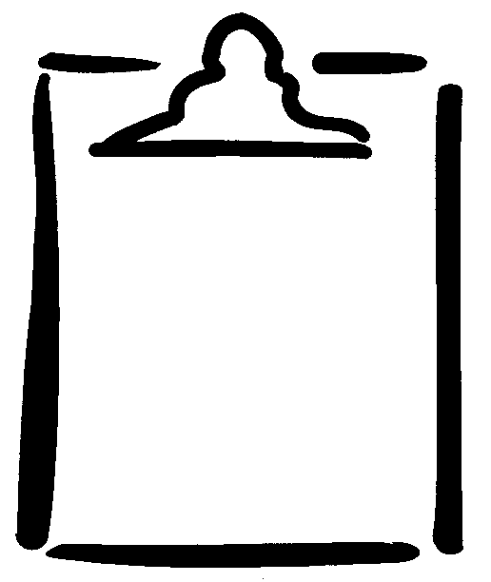  BLM  2-1.1
Name |  |  | Class | Date
How Adults Are Like Babies |  | How Adults Are Different from Babies

