RM 8–NU: Some Lifestyle Choices Lead to Energy Imbalance—
How Does It Happen?*

Energy
Expenditure

Energy
Expenditure
- activity
- metabolism

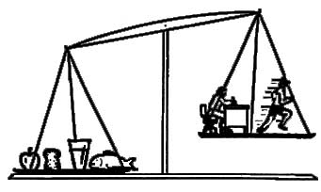
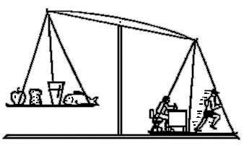

Energy
Intake
Energy
Intake

What factors contribute to an energy imbalance that could lead to weight gain?
What counter measures could help restore energy balance?

__________
* Source: Dairy Farmers of Manitoba, 2008, 2003. Adapted with permission.

